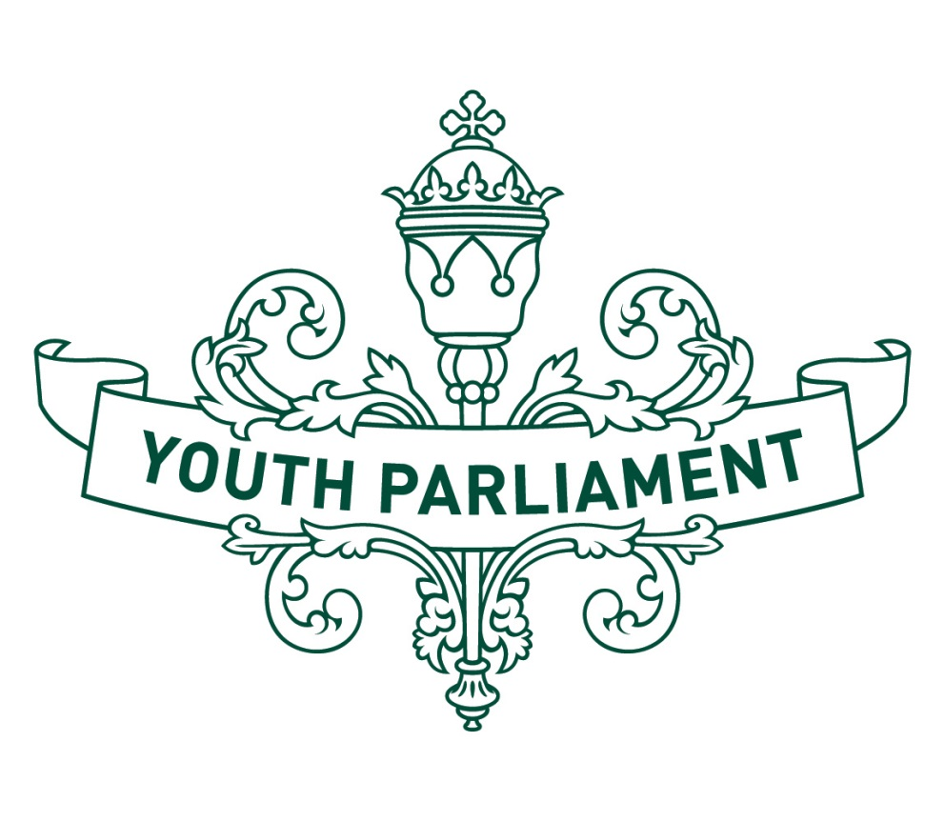
Youth Parliament 2016
Record of Proceedings:
Social Services
Select Committee report

Social Services Select Committee
Inquiry into what can be done to ensure that children of teen parents have good outcomes

Recommendations
The Social Services Select Committee makes the following recommendations to the Government:
That education services for teenagers, teen parents, families and whānau should be better promoted, targeted and strengthened
That mental health services and community support networks for teen parents should be strengthened
That the Ministry of Social Development should, in collaboration with relevant organisations, undertake focused research and collect data about the welfare of teen parents and their children
That Government funding should be targeted at areas of high need for teen parents and their children, as indicated by evidence-based research, including housing, education and mental health services
That the negative perception and stigma around teen pregnancy should be addressed through a concentrated, nationwide effort involving education and sensitive media portrayal to raise awareness about the existing services provided for teen pregnancy and parenting.

  - Introduction
Reducing vulnerability in early childhood has become a significant area of policy focus in New Zealand. The Government has identified a ‘good’ outcome for a child as where they can ‘thrive, belong and achieve’.
New evidence from New Zealand’s Integrated Data Infrastructure has identified a number of risk factors that increase the likelihood of children not reaching these outcomes. One of these factors is being the child of a teen parent.
We note that although the focus of this inquiry is on the outcomes of children of teen parents, it is often difficult to separate the outcomes of the teen parent (especially the mother) from those of their child. We have therefore also considered how teen parents can be supported so they can provide better outcomes for their children.
  - Characteristics of teen parents and their children in New Zealand
Although teen pregnancy in New Zealand is decreasing, international comparisons show that we have one of the highest rates of teen pregnancy in the Organisation for Economic Cooperation and Development (OECD), with young Māori and Pasifika women more likely to become teen parents than Pakeha women.
Research indicates that children with teen mothers are more likely to be born prematurely and at a low birth-weight, to repeat a year at school, less likely to complete secondary school and have lower performance on standardised tests than those born to older parents. They are also more likely to live in poverty and suffer higher rates of abuse and neglect. Daughters of teen mothers are also more likely to become teen mothers themselves, perpetuating these cycles.
Although we recognise the particular challenges and vulnerabilities that teen parents face, we note that not all children of teen parents have negative outcomes, and the circumstances that precede and follow teen births vary widely. Many teen parents express that having a child motivates them to make positive changes to improve outcomes for themselves and their children, and many teen parents and children thrive, belong, and achieve.
  - Good outcomes matter
Improving outcomes for teen parents and their children contributes to several Government priorities, including decreasing long-term welfare dependency, boosting skills and employment, and supporting vulnerable children.
A child’s negative early life experiences, including during pregnancy, such as exposure to stress, drugs, alcohol, neglect, or abuse, can severely affect physical and social development. Studies show that disadvantages in development and health tend to be accumulative. Therefore, reducing vulnerability early has the greatest likelihood of improving subsequent life outcomes and breaking cycles of vulnerability.

There is also a strong economic argument to improve the outcomes of children of teen parents. In New Zealand, teen parents spend about 17.5 years on a benefit, with an average lifetime cost per client of $213,000, and often require additional family support and health services.
  - Education
We consider that education should be a priority for all those affected by teen pregnancy. This education should be targeted, accessible and free. Organisations and community support networks should be sufficiently funded so they can provide full education services to all those affected by teen pregnancy.
  - Educating teenagers
We think that teenagers should receive sex education that is comprehensive, innovative and free from negative connotations. This education needs to include broader issues such as relationships, consent, contraception, and self-awareness. We note that the Ministry of Education has guidelines on sexuality education, and we would like to see schools flexibly incorporate them into their health education curriculums. We are aware that there are religious and cultural issues that need to be taken into account when discussing these topics; however we are confident that a sex education programme can be developed in accordance with these considerations.
  - Educating whānau and families
The Green Paper for Vulnerable Children notes that parents and caregivers have the largest impact on children and their childhoods. We consider that it is the responsibility of good governance to encourage environments where whānau and families are able to nurture and support vulnerable parents. The provision of education services for whānau and families of teen parents is crucial to ensuring that their children grow up to achieve good outcomes.
  - Educating teen parents
Continuing the education of teen parents after they have children is critical. We heard evidence from Teen Parent Unit, which provides secondary school education to teen parents, stating that the best way of creating good outcomes for teen parents and their children is to boost parental income and employment.
We recognise that not all teen parents will be in a position to continue secondary school education. We consider it is important that those teen parents have access to other parenting programmes which may provide practical skills.
We heard that in New Zealand, the Government has increasingly provided evidence-based support for teen parents and their children. Evaluation and anecdotal evidence suggest that parenting programmes in New Zealand are working effectively. Some outcomes measured include increased educational achievement for parents and their children, and the uptake of
immunisation and other health services. A significant result from the Family Start programme has been a decrease in post neo-natal mortality rates.
Although encouraged by these outcomes, we consider that there is still room for improvement in the delivery of these services. Some teen parents have reported feeling singled out due to negative preconceptions of their suitability as parents. Some felt judged, and became defensive, before withdrawing from the service being provided.
  - Strengthening mental health and community support services
Mental health and community support networks need to be visible and accessible. Teen parents are much more likely to participate in programmes or activities that are accessible by public transport or that provide transport to participants. Cultural accessibility is also an important consideration. For example, we understand that Māori principles and values play a central role when evaluating what works with Māori parents and whānau. Incorporating these values will increase the uptake and usefulness of these services.
We consider that it is more desirable to have an umbrella service, where families know they can always go, rather than a splinter network of different agencies that may not be known or trusted by families.
As part of continuing education about teen pregnancy, we would like to see the strengthening of infrastructure for mental health and community services associated with teen pregnancy. Mental health issues are becoming more and more prevalent in New Zealand, so we would like to see funding prioritised for the provision of these services. We accept that mental health issues can vary, but for the purposes of this inquiry we would like to see funding prioritisation for services associated with helping teen parents with issues like domestic violence, post-partum depression and anxiety.
Creating strong community support networks will positively affect the children of teen parents by entrenching them in the community and removing the negative impact of transience. This will be especially critical where a teen parent is isolated or where whānau are absent. As part of these community services, we would like to see the provision of accessible early childhood and healthcare programmes, cultural immersion programmes, mentoring programmes and extra-curricular activities for vulnerable children who may not otherwise be exposed to the benefits these provide.
Evidence shows that teen mothers parent better when they have social and emotional support from their child’s father. It is important that appropriate support is available for teen fathers to be involved in positive parenting. Support services to encourage teen fathers, including mentoring, advice, and fostering confidence, can help young fathers play a positive role in their child’s life.
  - Research and data collection
We are not satisfied that there is enough research and data collection about teen pregnancies, the welfare of teen parents and their children, or the provision of teen pregnancy support services. We would like to see comprehensive research done to identify
the most important factors in improving the welfare of teen parents and their children. Once this research is undertaken, funding should be reprioritised to fill any areas of need.
  - Perception of teen parents
We note that having a child at a young age should not necessarily be regarded negatively. Research suggests that Māori may be more accepting of teenage pregnancy as the continuation of whakapapa is central not only to Māori way of life, but is central to the continuation of life itself. Unfortunately for many New Zealanders, teen pregnancies are often considered with negative connotations, including by the teen parents themselves. This can negatively affect how they relate to themselves, their families, and ultimately their children. We heard from a submitter who had received negative judgement on his position as a teen parent. We would like to see a focus on the parenting, rather than the age of the parent. In order to change this perception, we would like to see a concentrated, nationwide effort involving education and sensitive media portrayal to raise awareness about the existing services provided for teen pregnancy and parenting.

  - Appendix to the Social Services Select Committee report
  - Committee procedure
The committee met on 19 and 20 July 2016 to consider the inquiry. The committee heard three submissions from the Ministry of Social Development, Noa Woolloff and Teen Parent Unit. We received advice from the Ministry of Social Development.
  - Committee members
Ruby Bridge (Chairperson)
Tebarae Amuera
Leah Bell
Aaron Dahmen
Tei Driver
Selena Gordon
Daniel Kelly
Jaistone Mataio
Abby May
Georgia Muller
Summer O’Dwyer
Dylan Parshotam
Beth Walters

The Green Paper for Vulnerable Children 2010 and The Children’s Action Plan 2012

