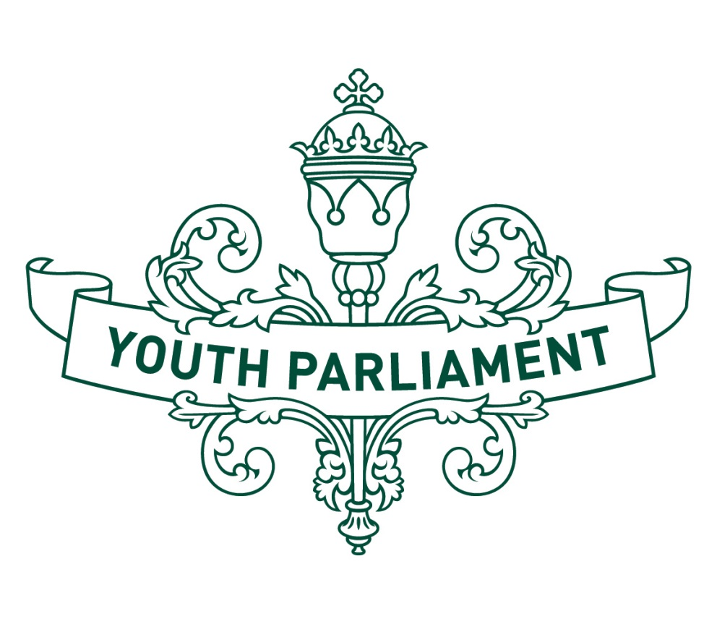  
Youth Parliament 2016

Record of Proceedings  
Māori Affairs Select Committee

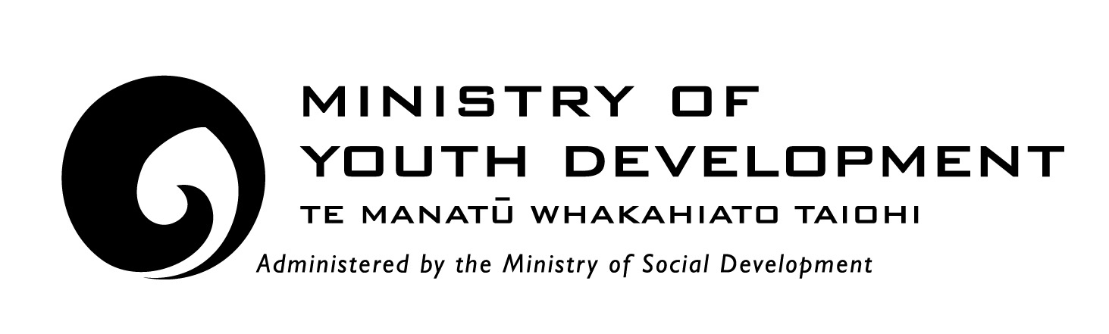



Māori Affairs Select Committee

**Inquiry into whether te reo Māori should be made compulsory in primary and secondary schools**

**Recommendations**

The report of the **Māori Affairs** Select Committee makes the following recommendations to the Government

that te reo Māori be made a core subject in school until the end of year 10 of High School

that te reo Māori be intergrated into the daily classroom life in Early Childhood Education (ECE) and primary and secondary schools, so that students are more likely to learn it later in their schooling. Each school could have one year to start implementing this

that each school has a tohunga to represent the Māori culture and be a te reo Māori expert. Each school could have a timeframe of 3-5 years to implement a tohunga

that schools are required to offer opportunities for students to visit marae and other culturally significant places, to learn more about the culture outside of school. These visits should occur at least once a term.

**Introduction**

The purpose of this report is to summarise our consideration of whether te reo Māori should be made compulsory in primary and secondary schools. Like all languages, te reo Māori is a gateway to understanding the culture of its speakers. From the national haka composed by Te Rauparaha (Ka Mate) to common place names, understanding te reo Māori provides a window into the world-view of Māori people and New Zealand’s heritage.

The last census recorded that only 3.7 percent of New Zealanders, and 21.3 percent of Māori, could hold a conversation in te reo Māori. This is down from 25 percent of Māori speakers in 1996, and comes in spite of a number of attempts to revitalise the language, including the confirmation of te reo Māori as an official language in 1987.

Making te reo Māori a compulsory learning standard in schools may support the revitalisation effort by supporting a whole generation of New Zealanders to have a basic grasp of the native language. However, a number of pros and cons have been presented to the committee regarding making te reo Māori compulsory in schools.

The committee defined a core subject as a compulsory subject within an early childhood centre or school.

**History of te reo Māori**

We are aware that since the 1860s, there has been a dramatic decrease in the proportion of Māori who are able to speak te reo Māori, which has been associated with a number of key historical events. These events include:

the establishment of the Native Land Act and Māori Land Court in 1865 to individualise the selling of Māori land.

the establishment of the Native Schools Act in 1867, which aimed to increase English literacy among Māori children. Te reo Māori was banned and children were punished for speaking te reo Māori.

the 1970s bought the revitalisation movement, with the establishment of Auckland-based Ngā Tamatoa, and Victoria University’s te reo Māori Society. Te Huinga Rangatahi petitioned Parliament to promote te reo Māori.

Māori Language week was first established in 1975.

the first Kohanga Reo was established in 1982.

the Waitangi Tribunal found that the Crown was obliged to protect te reo Māori as a taonga under the Treaty of Waitangi in 1985, and recommended a number of legislative policy changes.

te reo Māori became an official language in 1987 under the Māori Language Act.

in 2016, the new and amended Māori Language Act passed its third reading in Parliament, soon to be enacted into law.

**Te Pire Reo Māori (Māori Language Bill)**

This Bill is an update of the existing Māori Language Act 1987. It has a primary focus on revitalising te reo Māori at iwi, Māori, and community levels. It has five new key features:

1. a partnership approach where the Crown and Māori have distinct but complementary roles for revitalising te reo Māori.
2. dual language legislation with Māori prevailing in case of a conflict of meaning
3. an acknowledgement by the Crown of its contribution to the decline in te reo Māori
4. establishment of ‘Te Matawai’ to lead revitalisation of Māori language on behalf of iwi and Māori language strategies
5. two Māori language strategies
6. we heard from Timoti Brown, a Senior Policy Analyst from Te Puni Kōkiri who advised the Māori Affairs Select Committee on the Māori Language Bill. He explained the Bill to us in more detail.

We asked Mr Brown if we could use Local Government to help with these initiatives. The submitter agreed that because they are closer, they could help Central Government with Māori strategies. The submitter noted that the Bill gave Local Government more power to build relationships and empower Local and Regional Councils.

**Current policy settings for te reo in schools**

In primary and secondary schools, students have the choice of learning te reo through Māori-medium education and English-medium education. Māori medium education provides learners with a pathway to achieve educational success and proficiency in te reo Māori and is open to all learners in education, and not just Māori. It is taught in either total or near immersion te reo Māori. Students learn te reo Māori as an optional language subject.

The curriculum guidelines for teaching and learning te reo Māori is available to schools that wish to teach te reo Māori. This is not compulsory and schools are not required to deliver te reo Māori in their curriculum.

**Benefits of learning te reo Māori**

The Ministry of Education has categorised six main types of benefits of learning te reo Māori, as outlined in the Curriculum Guidelines for Teaching te reo Māori in English-medium schools. These are:

1. cultural benefits, where learning te reo Māori gives students access to the Māori world, and to the Māori world views
2. social benefits, giving students other ways to express themselves, so they can learn about the impact of the culture on people’s values, beliefs, and ways of thinking
3. cognitive benefits, help students to grow as learners. They discover more ways of learning, more ways of knowing, and more about their own capabilities
4. linguistic benefits, having more than one language gives students an awareness of language and how it works, which improves their understanding of their language and their ability to use it
5. economic and career benefits are possible with students that combine their Māori studies with other subjects such as business, law, trade, or teaching, increasing their career opportunities
6. increased sense of belonging and pride is present for students learning te reo Māori. They are able to communicate and participate more effectively as citizens of a multicultural society, and leads to personal satisfaction.

**International case studies**

Two case studies from overseas support these benefits. The Welsh desired to incorporate language in 1975 to become bilingual. This did not come into fruition in schools until 1987. Through government intervention, the Welsh have been able to revive their language to a point where, in 2014, almost a quarter of all primary school children in Wales were taught mostly in Welsh. In 2006, the fluency of Welsh had increased to 57 percent in the written language.

An Irish PhD student has spent the last six years studying te reo Māori. She is very engaged with the Māori language and watched Māori television online. She is engaging with te reo Māori through social media and is planning on visiting New Zealand once she finishes her doctorate.

**Submissions**

**Te Taura Whiri I te reo Māori**

We heard from Ngahiwi Apanui, who spoke on behalf of Te Taura I te reo Māori. He believes that te reo Māori should be made a core student subject like Mathematics, English, Science etc. in at least ECE and primary schools. He would ideally like to see it also made a core subject at High School as well.

The submitter said that it is the responsibility of every New Zealander to take ownership of the language. He affirmed that if we lost it here, it would be lost everywhere, as there is no other country we can go to get it back. He also said te reo Māori is our “x-factor.”

The submitter told us that research suggests identity, language, and educational success go together, and that there is a need to improve success rates to help our economy. The submitter noted that only 92 percent of Māori students have the ability to learn te reo Māori, which may hinder their educational success. The submitter pointed out that if Māori are more successful, they are more likely to help the economy.

We asked the submitter if kapa haka would be useful form of educating students about Māori culture. The submitter agreed that this can help, as it helps students realise that knowing the language helps them better understand kapa haka.

We asked what some of the challenges of compulsory teaching of the language would be. We heard that embarrassment can be a big factor, as students may feel lost when they first start learning the language if others are more advanced. The submitter also noted that a compulsory te reo curriculum could also be expensive to implement. It could take 3-5 years to set up professional development for teachers, and could cost around $150 million a year for that development. It could also be incorporated as a core component to all teaching courses. We agree that before you start implementing it, a strong foundation needs to be built through legislation so it is introduced smoothly.

We asked what some positive flow-on effects would be for teaching te reo Māori. The submitter told us he believes that te reo offers everyone an appreciation for the history of Aotearoa.

We asked what the submitter thought about the idea that making te reo compulsory is unfair. The submitter said he disagreed with this idea, but that until the majority agreed that te reo Māori was important, this was unlikely to change.

We heard that young people are the future of te reo Māori, and that engagement with the Māori language is increasing. We hope to see this engagement keep increasing in the future.

**Te Puni Kōkiri**

We heard from Willis Katene from Te Puni Kōkiri, who has a dream that te reo Māori is spoken throughout Aotearoa, and wants to halt the decline of speakers. The submitter does not think the best way to do this is to make te reo Māori compulsory, but rather to raise its value. The submitter believes that if we understand the value of the language, then we will elevate it, appreciate it, and therefore be more likely to use it. The submitter said this choice needs to be made available for both Māori and non-Māori.

Ideally, the submitter would like to see te reo Māori normalised. This would mean that teachers may give instructions in either te reo Māori or English, and this would be normal. We asked what would be the best way to normalise it. The submitter said just by using it, as the more who use and understand it, the more it will grow. The submitter also noted that teachers are very important, as they have to be passionate in te reo Māori.

The submitter noted that if you force people to learn something they don’t want to learn, it can be bad. The submitter gave the example of people walking out when she taught them the Ka Mate haka. Some people walked out of this session and this was upsetting for those teaching, as this haka was very important to them. This is why the submitter thinks learning te reo Māori should be a choice.

**Māori party minority view**

It is the view of the Māori Party member Te Paki McKenzie that te reo Māori should be a core subject in addition to the seven core curriculum subjects. It is our belief that the te reo Māori is a unifying face for nationhood, and has the ability to reduce unconscious bias in New Zealand society thereby improving the incidence of equitable outcomes.

We note that Kii Winston Small, Te Puawai Wilson-Leahy, Josh Gill, and Katie Gotileb also agree with this minority view.

**Appendix to Māori Affairs Select Committee report**

**Committee procedure**

The committee met on 19 and 20 July 2016 to consider the inquiry into whether te reo Māori should be made compulsory in primary and secondary schools. The committee received and heard three submissions. Evidence was heard from Te Taura Whiri I te reo Māori and Te Puni Kōkiri. We received advice from Te Puni Kōkiri.

**Committee members**

Kii Winston Small (Chairperson)

Kane Bassett

Alexander Croft

Levi Farrell

Finnian Galbraith

Josh Gill

Katie Gotlieb

Te Paki McKenzie

Crystal Te Moananui

Ngahuia Muru

Stacey Rose

Te Puawai Wilson-Leahy