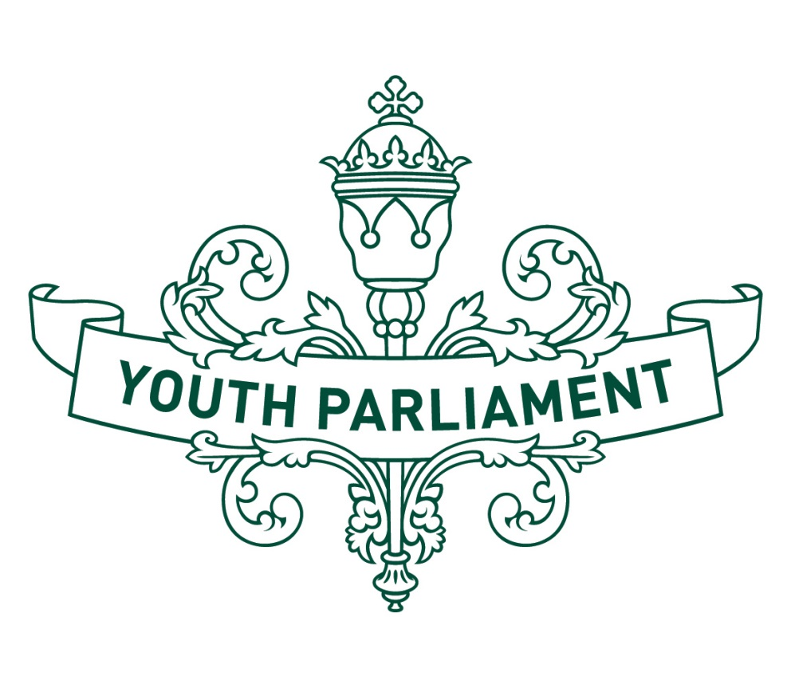
Youth Parliament 2016
Record of Proceedings:
Education and Science
Select Committee report
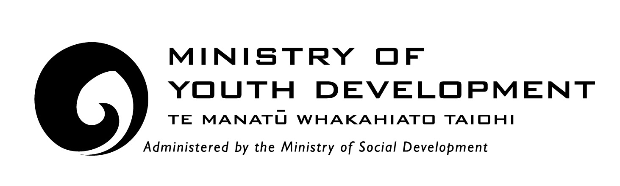

Education and Science Select Committee
Inquiry into whether schools should be required to be more accessible to the Lesbian, Gay, Bisexual, Transgender and Intersex community

Recommendations
The Education and Science Select Committee makes the following recommendations to the Government:
- that the Human Rights Act 1993 be amended to prohibit discrimination on the grounds of gender identity
- that it require all state and state-integrated schools to improve their LGBTI-inclusive approach by such actions as implementing gender neutral facilities, peer support groups, and allowing same-sex partners at all school events
- that it instruct the Education Review Office, as part of its usual review process, to evaluate and report on the gender inclusiveness of all schools and their treatment of LGBTI students
- that it require all state and state-integrated schools to carry out annual anonymous surveys to evaluate how accessible their school is to LGBTI students
- that it encourage the Ministry of Education, the Human Rights Commission, and people from the LGBTI community to work together to develop an education programme that can be integrated into current teacher training programmes. The programme should be directed at both current and prospective school staff, to raise awareness of LGBTI issues
- that it instruct the Ministry of Education to integrate gender and sexual diversity as a compulsory part of the school curriculum that is taught consistently across all state and state-integrated schools.
  - Introduction
The purpose of this report is to summarise our consideration of the accessibility of schools to the Lesbian, Gay, Bisexual, Transgender, and Intersex (LGBTI) community.
The primary piece of legislation governing the New Zealand education system is the Education Act 1989. Under Section 61 of the Act, Boards of Trustees are required to set out their school’s objectives every year. These objectives must give effect to the Government’s National Education Guidelines, including the National Administration Guidelines (NAGs). NAG 5a requires Boards of Trustees to provide a safe physical and emotional environment for students.
In addition to complying with the NAGs, schools are also subject to the Human Rights Act 1993.
  - LGB students compared to non-LGB students
According to Youth’12 survey, 3.8 percent of New Zealand secondary students are attracted to the same or both sexes. These students are more likely to report bullying, depressive symptoms and attempting suicide than students who only reported attraction to the opposite sex.
  - Transgender students
Transgender people are those whose gender identity differs in any way from the gender they were assigned at birth. Of the students who responded to the Youth’12 survey, 1.2 percent reported being transgender and 2.5 percent reported being unsure about their gender. Transgender students were more likely to report concerns about their personal safety and poor mental health than cisgender students (those whose gender identity is the same as the gender they were assigned at birth).
The Human Rights Commission inquiry into discrimination experienced by transgender people identified a number of difficulties faced by transgender children and young people in New Zealand schools. These include:
schools refusing to use the student’s chosen name
students required to wear the uniform of the gender they were assigned at birth
difficulties in participating in preferred sporting teams and events that are sex-segregated.
  - Intersex students
Intersex people are those born with reproductive or sexual anatomy that does not fit the typical biological definitions of male or female. There is no reliable data on intersex people in New Zealand. Estimates are that between one in 5,000 and one in 10,000 people are born intersex, depending on how this is defined.
  - Reform of the Human Rights Act 1993
Section 21 of the Human Rights Act 1993 prohibits discrimination on the grounds of sex and sexual orientation. However, the law is unclear as to whether the prohibition against sex discrimination also includes discrimination on grounds of gender identity. We recommend that the Act be amended to specifically prohibit discrimination on the grounds of gender identity.
  - Improving the LGBTI-inclusive approach in state and state-integrated schools
  - Gender neutral facilities
The 2015 Sexuality Education Guidelines suggested that schools review options around toilet facilities to ensure that students have choices of safe spaces. A resource for schools published recently by InsideOUT, has recommended that transgender students have access to gender neutral facilities, as well as being able to use the bathroom that corresponds with their gender identity.
We suggest that schools implement gender neutral bathrooms so that their students do not need to choose whether to use a “male” or “female” bathroom.
  - Peer support groups
Peer support groups such as Queer Straight Alliances (QSA) provide a safe space for LGBTI students to socialise and promote greater acceptance of gender and sexual diversity within their school. Students in schools with these types of support groups report less harassment and bullying based on sexual orientation or gender identity, and are also more likely to feel a sense of belonging to their school.
We are of the view that all schools should have the opportunity to create a QSA group or similar peer support group, without barriers, to ensure that students feel more comfortable and supported at school. We think that these groups should be implemented regardless of whether or not the school thinks there are any LGBTI students attending.

  - Same sex partners at school events
In order to acknowledge sexual diversity in schools and avoid discrimination on the grounds of sexual orientation, we recommend that all schools allow same-sex partners to attend all school events.
  - Review of LGBTI-inclusive approach in schools
The Education Review Office (ERO) is the New Zealand government department that evaluates and reports on the education and care of students in schools. ERO’s reports are used by parents, teachers, school principals and trustees, and by government policy makers. We recommend that ERO evaluate and report on the gender inclusiveness of schools and their treatment of LGBTI students.
Alongside ERO reviews, we also recommend that state and state-integrated schools carry out annual anonymous surveys in order to measure the accessibility of the school to their LGBTI students. Surveys should consider sexual orientation and gender identity of students and the level of bullying and harassment occurring at school. Importantly, surveys should ask whether students feel safe, included and supported at school. The results of these surveys should be available to ERO. We think that on-going review is required to ensure that schools are adequately facilitating for all their students.
  - Education
We agree with all three submitters that increasing education and awareness of the issues faced by the LGBTI community are essential to making schools more accessible.
  - Ongoing professional development of school staff
We recommend that the Ministry of Education, together with the Human Rights Commission and people from the LGBTI community develop an education programme to ensure that schools are accessible to the LGBTI community. This education programme should become a compulsory part of the teacher education qualification and also become part of the ongoing professional development of current teachers.
We strongly endorse and encourage the use of the diversity education workshops that are carried out by organisations such as the Post Primary Teachers’ Association Rainbow Taskforce.
  - Sex and sexuality education in schools
All state and state-integrated schools in New Zealand are required to provide teaching and learning programmes within the framework of the National Curriculum (NAG 1). The principles of the curriculum require that a school’s curriculum be inclusive (“non-sexist, non-racist and non-discriminatory”) and recognise and affirm students’ identities.
The Ministry of Education Sexuality Education Guidelines (2015) incorporates LGBTI issues into its suggested learning intentions. For example, at Level 4 of the curriculum, the suggested learning intentions include:
describing personal gender identity and critiquing media messages about gender, relationships, and sexuality
identifying the influence of gender and sexuality stereotypes on self-worth
critiquing heteronormative messages and practices in school and media
developing policies for supporting diversity of gender and sexual identities.
We support the inclusion of LGBTI issues into the Guidelines but think that more needs to be done to ensure that sex and sexuality education is consistent across all schools in New Zealand. We note that acknowledgement of gender and sexual diversity in sex education is important for promoting the sexual health of LGBTI students and would like this to be a compulsory part of the school curriculum.

  - Appendix to the Education and Science Select Committee report
  - Committee procedure
The committee met between 19 July 2016 and 20 July 2016 to consider the inquiry. The committee received and heard three submissions. Evidence was heard from InsideOUT, PPTA Rainbow Taskforce, and VUW School of Law; and advice was received from the Ministry of Education.
  - Committee members
Karan Kalsi (Chairperson)
Bianca Bailey
Jessica Boniface
Kate Chew-Lit
Beth Clearwater
Chloe Destrieux
Sophie Harrison
Keziah Lawes
Kasey McDonnell
Carragh McKay
Tim Ryan
Grahame Woods

Adolescent Health Research Group, Youth’12 Prevalence Tables (2013), https://www.fmhs.auckland.ac.nz/assets/fmhs/faculty/ahrg/docs/2012prevalence-tables-report.pdf, p.121.
For a discussion on this, see the Human Rights Commission inquiry (2008), pp. 88–93.

