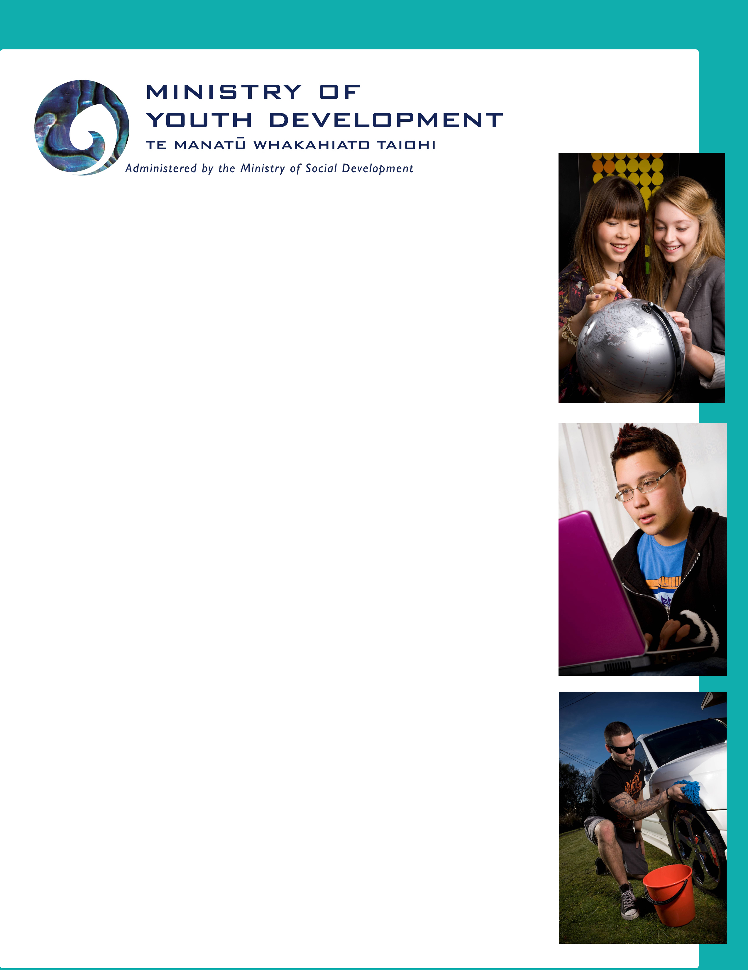
Law Commission Review: Sale and Supply of Liquor

Youth Friendly Survey Findings

December 2009

TABLE OF CONTENTS

ABOUT THIS REPORT 3
What’s in this report? 3
How it happened? 3
What was the result? 3
What did we find from this survey? 4
SUMMARY OF RESPONSES 5
Attitudes to drinking 5
Education 5
Tax and pricing 6
Minimum purchasing age 8
Responsibility 10
Restrictions 10
Packaging 12
Enforcement 12
Treatment 13

ABOUT THIS REPORT

What’s in this report?
This report contains a summary of the views of young people who participated in the youth friendly survey on the sale and supply of liquor in New Zealand. In this report you will find out what these young people said about the issues and their ideas.

How it happened?
The Law Commission wanted to know people’s views on the sale and supply of liquor in New Zealand and were keen to let the youth of New Zealand have their say. To make sure young people got involved, the Law Commission and the Ministry of Youth Development created a survey just for young people. This survey covered 11 issues relevant to young people on the sale and supply of liquor. These issues were:
- Attitudes to drinking
- Tax and pricing
- Minimum age
- Responsibility
- Hours
- Off-licence
- Product labelling
- Advertising
- Enforcement
- Public places
- Treatment.

What was the result?
The Ministry of Youth Development received 171 submissions from young people and developed a report. The report was sent to the Law Commission on 24 November 2009 and will be used along with the submissions received through the public consultation process (submissions mostly by adults) to develop a final report Alcohol in Our Lives which will go to the Minister of Justice in 2010.

What did we find from this survey?
The findings of the youth survey showed various levels of support from the young people for:
- increasing taxation on alcohol
- retaining a minimum purchasing age of 18 years
- giving consideration to legislating for a minimum drinking age
- encouraging greater parental and self responsibility while drinking, and for actions whilst drunk
- more education on the harms of dangerous drinking
- potentially restricting the hours that some licensed premises are able to sell alcohol
- introducing health warnings on the labels of alcohol products as a legal requirement
- restricting some of the ways in which alcohol is currently advertised and promoted
- greater enforcement and policing of the laws around purchase and consumption of liquor
- introduction of treatment facilities to help people sober up.

The Ministry of Youth Development would like to thank all the young people that chose to take part in this survey.

SUMMARY OF RESPONSES

Attitudes
Most young people (59%) thought that getting drunk was OK. The following table shows young people’s responses.
Do you think getting drunk is ok? | %
Yes | 59%
No | 41%

Education
There was strong support from young people for more education on the harms of dangerous drinking.
The majority (47%) of young people thought that there wasn’t enough understanding of the risks associated with heavy drinking. The following table shows the range of young people’s views.
Do you think people understand the risks associated with heavy drinking? | %
Yes | 37%
No | 47%
Not sure | 16%

Those that thought people do not understand the risks associated with heavy drinking suggested the following to assist people to better understand these risks:
- greater education/awareness raising around the risks, particularly in schools and aimed at younger drinkers (52%)
- advertising of the risks, e.g. through labelling as is the case with cigarettes.

“…all we ever get told is “it’s not drinking it’s the way we’re drinking” that’s ridiculous how about telling people what is wrong with the way we are drinking, ie, how many people die from alcohol each year?” (male 15 years)

Tax and pricing
There was less support for increasing the taxation of alcohol as a way to reduce young people’s drinking of alcohol.
The majority of young people (47%) said an increase in the tax on alcohol would not make them drink less. The following graph shows young people’s views on how an increase in the tax on alcohol (making it more expensive) would affect their drinking.
Do you think an increase in the tax on alcohol (making it more
expensive) would make you drink less?
Yes
No
Not sure

19%
34%

47%

Of the people that thought an increase in alcohol tax would not influence how much alcohol they drank, the following responses were given:
- price is not an issue
- people will just borrow money in order to be able to drink
- don’t drink much/enough for it to make a big difference
- it would influence what we drink, but not how much we drink.

“Young people will always buy alcohol regardless of price.” (female 17 years)
“We only have a glass of wine at home with a meal.” (male 18 years)
“If anything increasing the price would encourage people to purchase alcohol spirits over beer and wine. Higher alcohol, more cost-effective.” (female 20 years)

The following graph shows young people’s views on whether the difference in price of alcohol, influences the where they drink.
Do you think that the difference in price between alcohol bought
from a liquor store and alcohol bought in a bar or restaurant
influences where you drink?
0.0%
10.0%
20.0%
30.0%
40.0%
50.0%
60.0%
70.0%
80.0%
Yes
No
Not sure

Of those that agreed that the price of alcohol influenced where they would drink, 28% indicated they [and their friends] were likely to drink at home before going out, so they could better afford it.
“Most people buy cheap alcohol before going into town and drink it as fast as possible at home.” (male 19 years)

Most young people (65%) agreed that cheap alcohol contributes to alcohol-related harm. The following graph displays the range young people’s views.

Do you think that cheap alcohol contributes to alcohol-related harm?
0.0%
10.0%
20.0%
30.0%
40.0%
50.0%
60.0%
70.0%
80.0%
Yes
No
Not sure

Minimum age
There was strong support from young people to keep the minimum purchase age of alcohol at 18 years old. The following table shows the range of young people’s views on the minimum purchasing for alcohol.

At what age should a person be able to legally buy alcohol in New Zealand? | %
18 | 58%
19 | 4%
20 | 17%
21 | 21%

There was also strong support (64%) for the age people should be able to legally drink in a pub, club, bar or restaurant to stay at 18 years old. The following table shows the range of young people’s support.

At what age should a person be able to legally drink in a pub, club, bar or restaurant? | %
18 | 64%
19 | 6%
20 | 13%
21 | 17%

“In regards to having a minimum drinking age, I do not believe this will be effective, as allowing children to have a little bit every now and then helps to teach them to be responsible. In many cases, it is the people who have never had alcohol that go wild when they turn 18.” (female 20 years)

Despite the above support for keeping the current age restrictions, the majority (45%) of young people thought that there should be changes to the current alcohol laws around alcohol and age. One of the most supported options was to introduce a minimum drinking age. The following table shows young people’s support for this option (at present New Zealand only has a minimum purchase age for alcohol).

Introduce a minimum drinking age, so you can't drink alcohol until you reach this age (rather than having a purchase age). | %
Yes | 45%
No | 42%
Not sure | 13%

Responsibility
Most young people supported encouraging greater parental and self responsibility while drinking, and for actions whilst drunk. In particular, a majority of the young people (60%) thought it should be illegal for a person, other than a parent or guardian, to give alcohol to someone under the age of 18. The following table shows young people’s support for this option.

Should it be illegal for a person (except a parent or guardian) to give alcohol to someone under the age of 18? | %
Yes | 60%
No | 27%
Not sure | 13%

“Parents should be allowed to supply their children with alcohol because generally a parent can be trusted to teach their children how to drink responsibly and only supply them with alcohol when they are responsible enough to handle it. However a person other than the legal parent or guardian won't necessarily act in this manner.” (male 18 years)

Restrictions
When presented with a range of options, a slight majority (51%) thought there should be changes to the current laws around hours in which alcohol may be sold. The most favoured option was to restrict the opening hours of all off-licences, as the following table displays.
Restrict the opening hours of all off-licences (bottle stores and supermarkets), for example from 8am to 10pm on a nationwide basis? | %
Yes | 53%
No | 37%
Not sure | 10%

The largest percentage of young people that responded (48%), supported the option of restricting bars and restaurants from selling alcohol after 2am, as the following table displays.
Restrict on-licence premises (bars and restaurants) from selling alcohol after 2am nationwide? | %
Yes | 48%
No | 40%
Not sure | 12%

The largest percentage of young people that responded (47%), supported more restrictions on how alcohol is advertised. The following table shows the range of young people’s views around alcohol advertising.
Should the way alcohol is advertised (including advertising, promotions and sponsorship) have greater restrictions? | %
Yes | 47%
No | 40%
Not sure | 13%

Of the people that agreed that there should be greater restrictions on the ways in which alcohol is advertised (47%), the following suggestions were mentioned:
- no advertising on television (20%)
- a total ban on all forms of advertising (16%)
- no billboard advertising (9%)
- prohibit sponsorship of sports teams by alcohol brands (7%)
- limit times when alcohol may be advertised (7%).

Packaging
We asked young people about the use of health warning labels on alcohol products, the majority (71%) of young people said that these labels should be included on alcohol products. The following table shows young people’s views on including health warning labels.
Require health warning labels on alcohol products? | %
Yes | 71%
No | 20%
Not sure | 9%

We also asked young people what they thought about regulating how alcohol is packaged, promoted and displayed. The following table shows young people’s views.
Regulate packaging, promotions, point of sale placement and display of alcohol products? | %
Yes | 59%
No | 30%
Not sure | 11%

“The OVERALL societal effects of alcohol is more harmful than smoking, similar health/social impact warnings should be placed on all bottles.”
(male 24 years)

Enforcement
The majority of young people supported having greater enforcement and policing of the laws around the purchase and consumption of liquor.

Most young people thought that there should be harsher penalties for serious breaches of liquor laws. The following table shows the range of young people’s support for harsher penalties.
Should there be harsher penalties for serious breaches of the liquor laws? | %
Yes | 54%
No | 34%
Not sure | 12%

Those that disagreed (34%), explained their position by offering the following views:
- attitudes need to change instead (35%)
- the existing fines are fair (24%)
- policing should be increased instead (18%).

“There is a perception that underage drinking is unlikely to be punished and even if it is that there will be only a very light punishment.” (female 17 years)

Treatment
The majority of young people supported the idea of providing a centre for people to sober up when there is a concern for their own or others’ safety or health. The following table shows the views of young people on these centres.
Do you think there is a need to provide a centre for people who are drunk and/or where there is a concern for their own or others' safety or health? | %
Yes | 61%
No | 24%
Not sure | 16%

Of those that agreed, their most common reasons were:
- if they pose a risk to themselves or others (31%)
- to provide support and to allow people to reflect on their behaviour and learn (28%).
Of those that disagreed, their most common reasons were:
- use Police cells instead (30%)
- waste of money/resources (26%)
- should be encouraging/teaching people how to drink responsibly instead (22%).
Of those that were unsure, most thought it would be too expensive to have these centres (40%).

“This is a great initiative for people who do get drunk and don’t realise what’s happening, when they’re sober they will regret it, making them learn their lesson, also a great place for drunk people to be out of harm’s way of hurting others.” (male 15 years)

