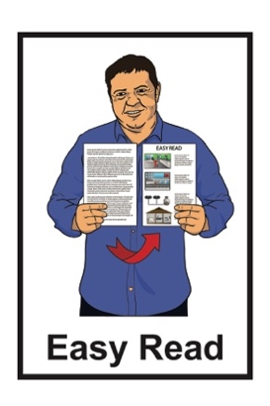
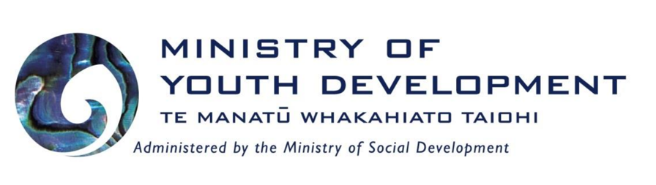
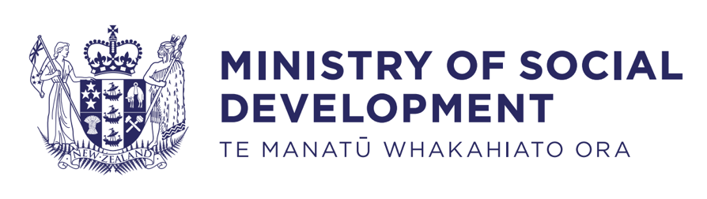

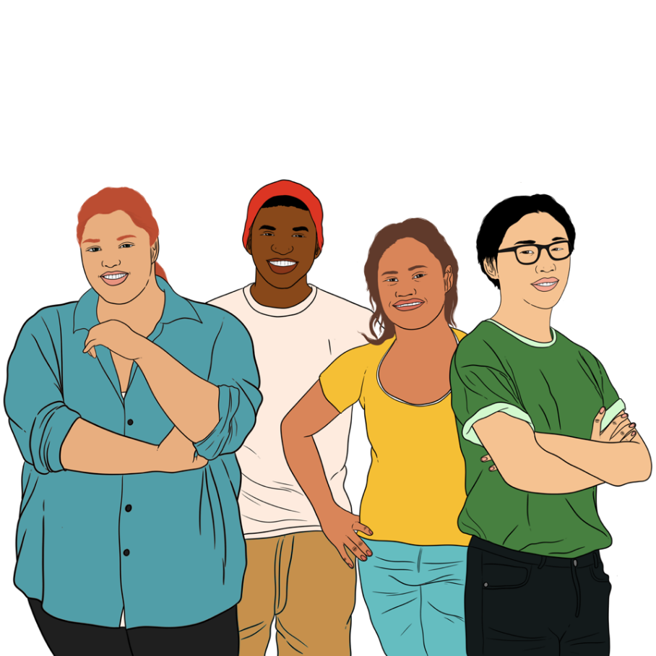
Summary of the Youth Plan: Voice, Leadership, Action
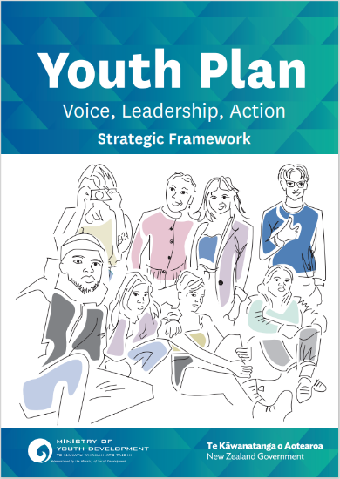

Published: August 2023

What you will find in here


Page number:

About this document 3
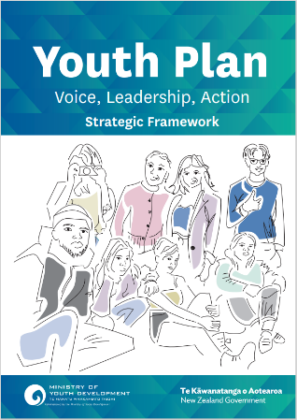

What is the Youth Plan? 5

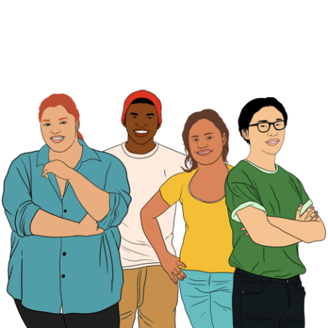
Who is the Youth Plan for? 8

What are the aims of the
Youth Plan? 13

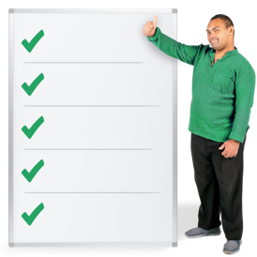
What are the outcomes of the
Youth Plan? 17

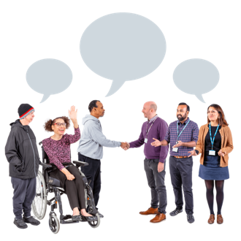
Page number:


How will government agencies
support the Youth Plan? 22

Tools to support the Youth Plan 24



Tool 1: Mana Taiohi 25

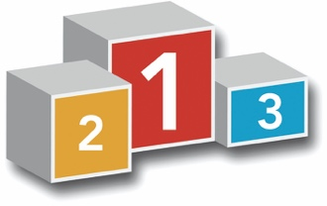
Tool 2: Priority cohorts 29
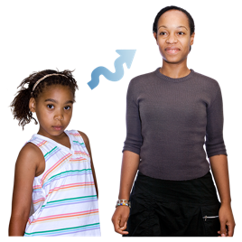

Tool 3: Age range 31


Tool 4: Engagement
Continuum 34

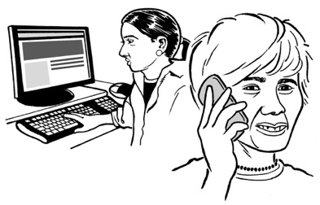
Where to find more information 38

About this document


This Easy Read document is from the Ministry of Youth Development –
Te Manatū Whakahiato Taiohi.

It is a summary of a plan called:

Youth Plan: Voice, Leadership, Action

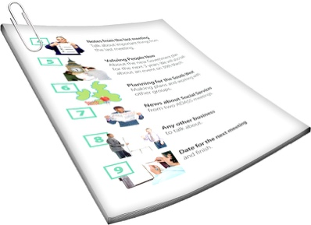
A summary:
is shorter than the full document
tells you the main ideas.
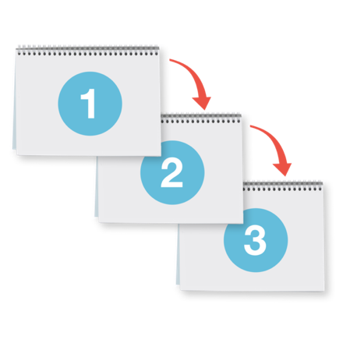

A plan sets out the steps for how to do things so a person / group of people can reach a goal.
In this Easy Read document will call the Youth Plan: Voice, Leadership, Action the Youth Plan.


You can read the full Youth Plan on the Ministry of Youth Development website at:



https://tinyurl.com/29c97k29

The full plan is not in Easy Read.

What is the Youth Plan?

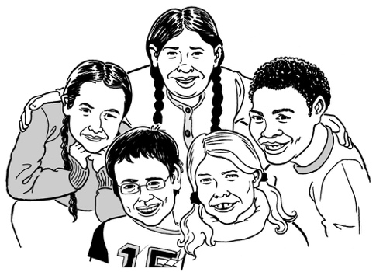
The Youth Plan sets out changes that need to happen to better support young people in Aotearoa New Zealand.
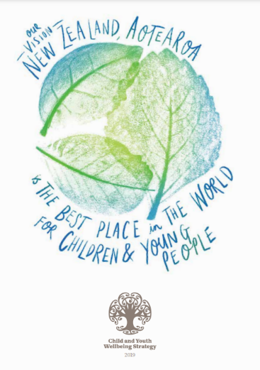

It is part of a bigger plan called the Child and Youth Wellbeing Strategy.

Wellbeing is about people:
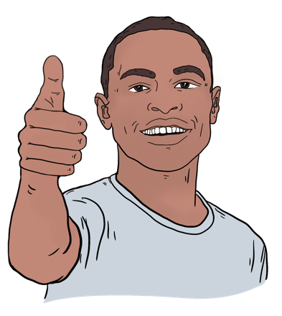
being healthy
being happy
having a good life.

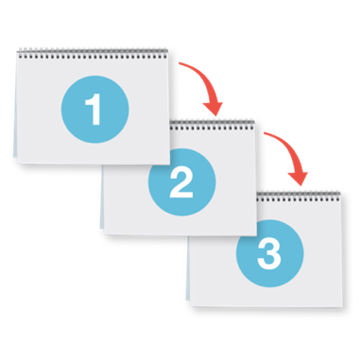
A strategy is another name for a plan.

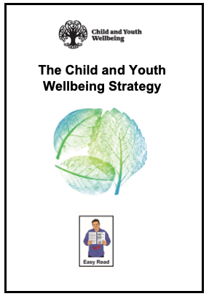
You can find an Easy Read version of the Child and Youth Wellbeing Strategy online at:

https://tinyurl.com/bdf5u3je

The Child and Youth Wellbeing Strategy sets out 6 outcomes.
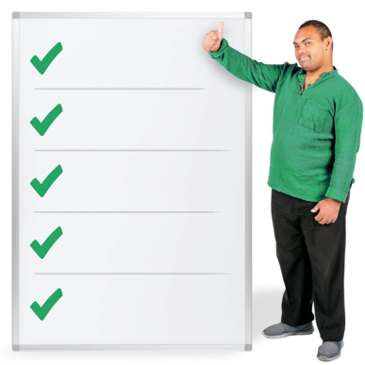

Outcomes are things that should happen as a result of work that is done.

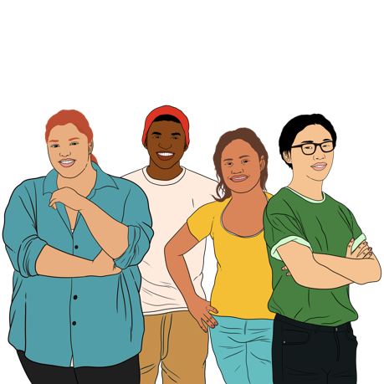
The Youth Plan is part of outcome 6 of the Child and Youth Wellbeing Strategy that says:

Children and young people are involved and empowered.

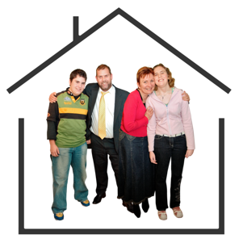
This wellbeing outcome means children and young people are a part of / assist with things that happen:
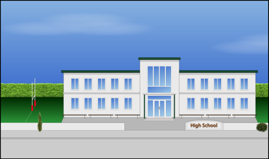
at home
at school
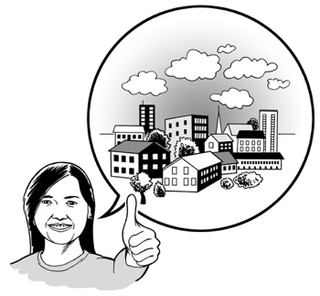
in their communities.

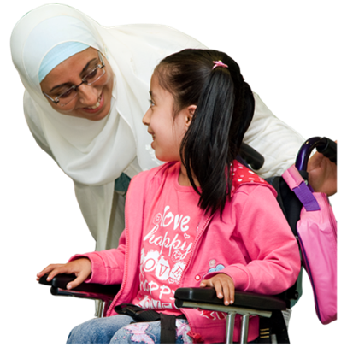
This wellbeing outcome also means that children and young people:
are listened to
have the support they need to grow into happy / healthy adults.

Who is the Youth Plan for?


There are around 8 hundred and 50 thousand young people living in Aotearoa New Zealand.

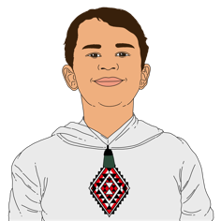
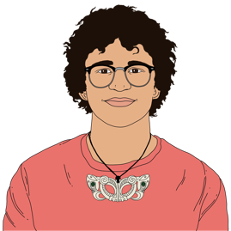
Young people in this document means people who are 12 years to 24 years old.
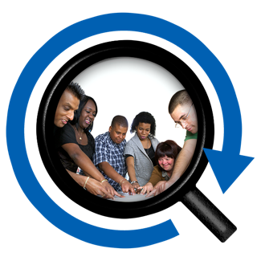

The Youth Plan looks closely at 7 groups of young people.

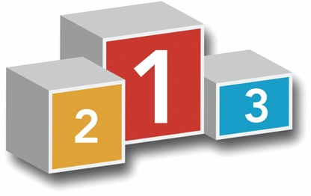
In the Youth Plan the 7 groups are called priority cohorts.
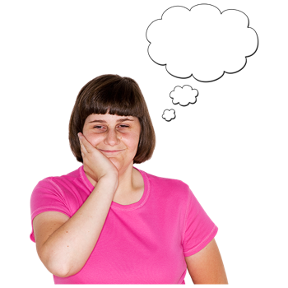

Priority cohorts means the needs of the young people in the 7 groups should be thought about first.
There is more information about priority cohorts on pages 29 to 30.
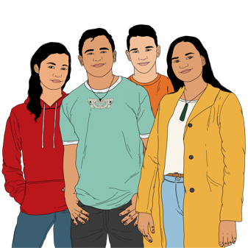

The 7 priority cohorts are:
rangatahi Māori / young Māori
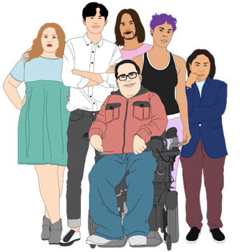
Pacific young people
rainbow young people
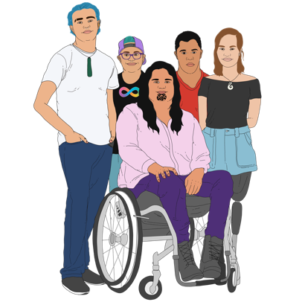
disabled young people
young women
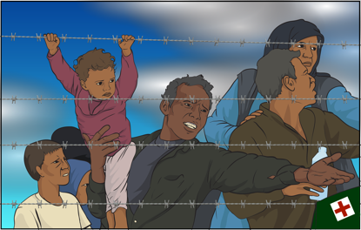
young people from ethnic communities including:
- refugees
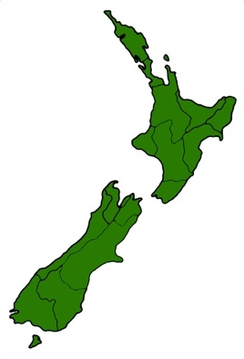
- migrants
young people living in the regions.
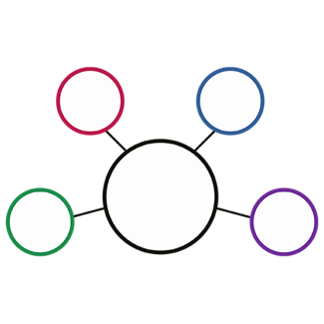
Some young people may be in more than 1 group.

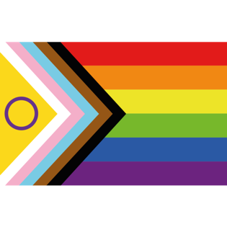
Rainbow young people means young people who are LGBTTIQ+.

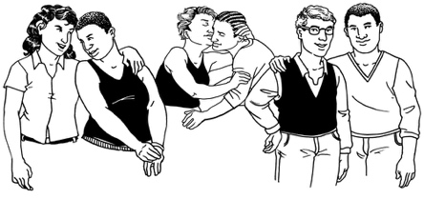
LGBTTIQ+ stands for people who are:
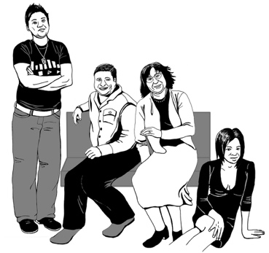
lesbian
gay
bisexual
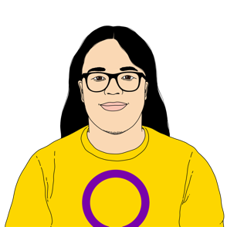
transgender
takatāpui
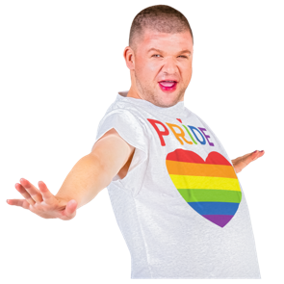
intersex
queer
others such as asexual people.
Being LGBTTIQ+ can also be about:
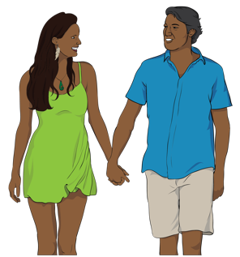
your gender which is if you are:
- male / a man
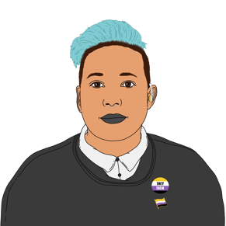
- female / a woman
- another gender like
non-binary

the kinds of people you are attracted to.

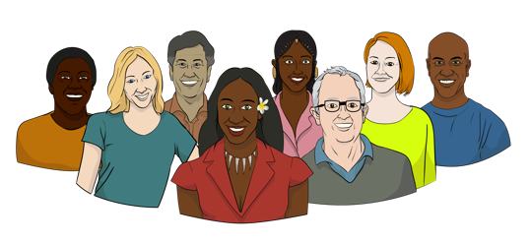
Ethnic communities are people from other cultures / countries.

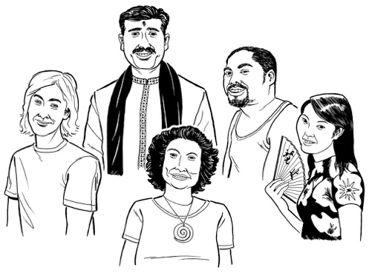
Culture is a way of:
thinking that a group of people share
doing things as a group.
Refugees are people who have come here to be safe from harm in their home country.
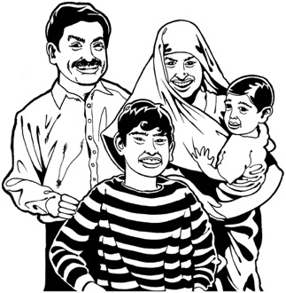

Migrants are people who have moved here from other countries.

The regions means places outside of the main cities of Aotearoa New Zealand.

What are the aims of the Youth Plan?


The Youth Plan aims to make sure that young people are:

listened to
involved in making decisions about their own lives
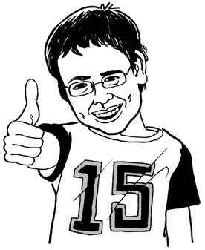
able to have their say about the things that affect them.

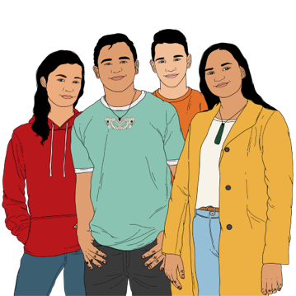
The Youth Plan says the mana of young people is made stronger when:
they can lead their own lives
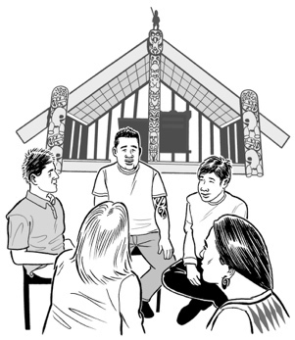
they are seen for who they are
they have a greater say in things that affect them.

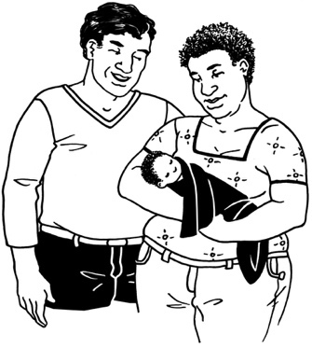
Māori believe that everyone has mana from the time they are born.

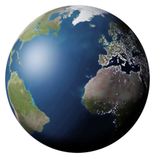
Mana is the spiritual life force / power that is found in all of the universe.

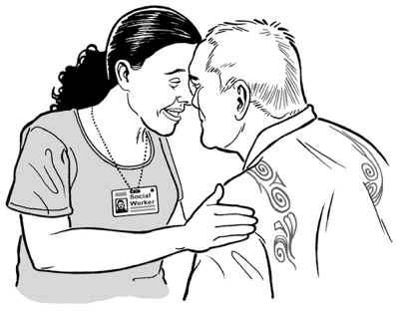
Having mana:
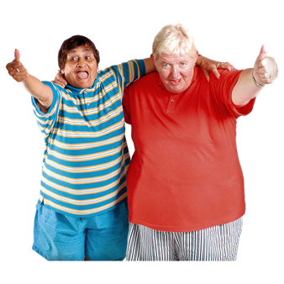
means someone has a strong sense of confidence / knowledge about them
might affect how other people see / think about them.

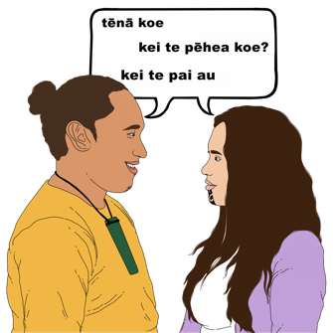
Young people can gain more mana throughout their lives:
by the things they do
through the choices they make.

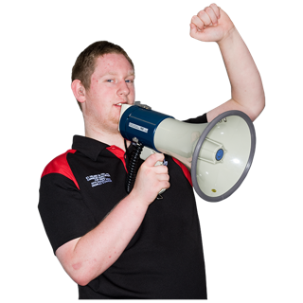
The Youth Plan looks at 2 main areas:

voice
leadership.

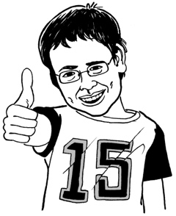
Voice is about:
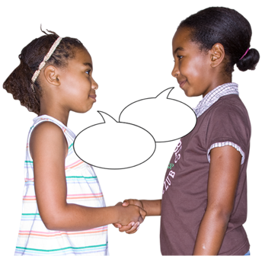
giving young people the chance to speak out about things that are important to them
listening to what young people say.

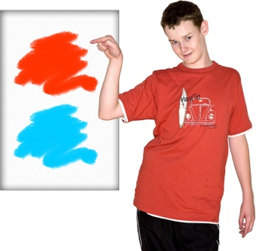
Leadership is about giving young people the chance to make / be a part of decisions that affect them.

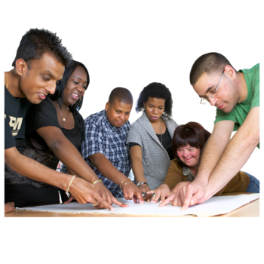
Voice and leadership are a part of whai wāhitanga.

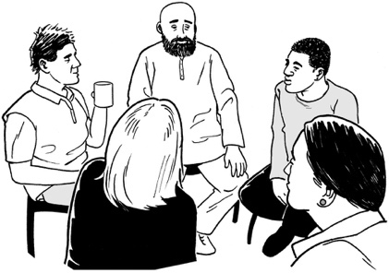
Whai wāhitanga means participation which is about taking part in things.

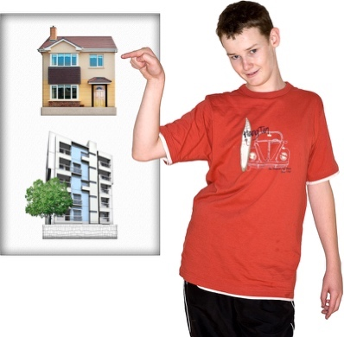
It also means that young people can take an active part in making choices about things that affect them.

Whai wāhitanga:
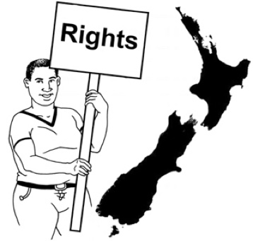
sees mana in every young person
gives all young people the power to have a say in their own lives.

What are the outcomes of the Youth Plan?

The Youth Plan also has outcomes.

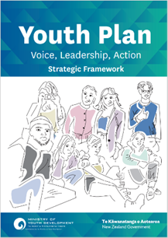
The outcomes of the Youth Plan are different to the outcomes of the Child and Youth Wellbeing Strategy.

The 6 outcomes of the Youth Plan are:
- All young people are supported to:
- be the people they want to be
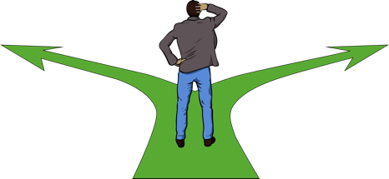
- make good choices that add to their mana.

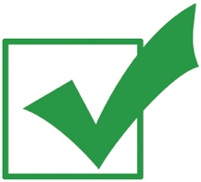
Other outcomes of the Youth Plan are:

- The mauri of young people is made stronger so that other people see young people:
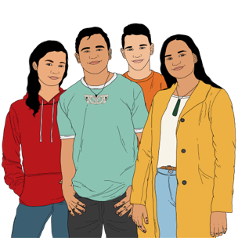
- for who they are
- who they want to be.


Mauri is a way of saying everyone has a spark of life inside them that is part of who they are.

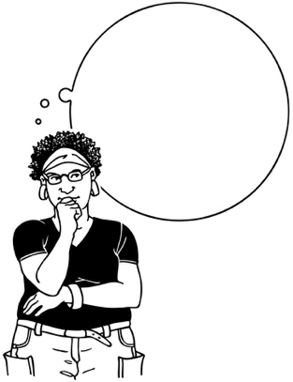
Mauri is also a part of:
the things people are good at.
the things people believe.

Other outcomes of the Youth Plan are:
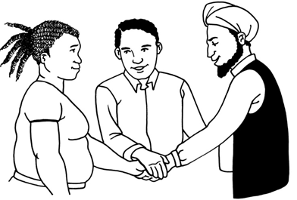
- The whai wāhitanga of young people is seen / made stronger by giving them the chance to be involved in the things that affect them.

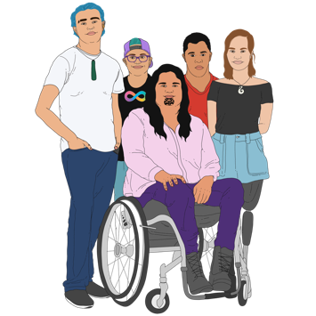
- Young people who are part of the 7 priority cohorts are given chances to make:
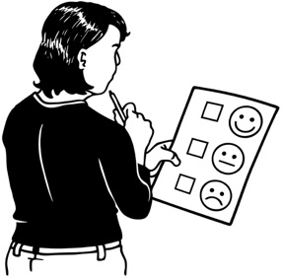
- changes to things that affect them
- these changes in the ways they want to.

Other outcomes of the Youth Plan are:
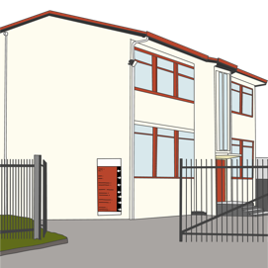
- Young people get the support they need to get into:

- education like school / college
- the kind of job they want
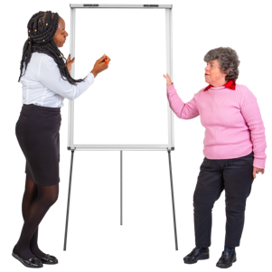
- training to get the skills they want / need.

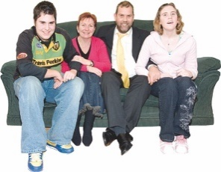
The support for young people in outcome 5 should come from:
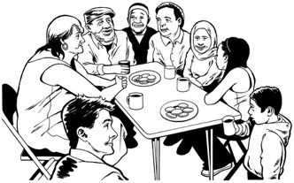
their whānau / family
their community
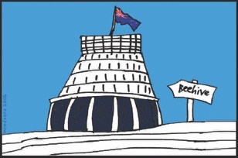
the Government.

The final outcome of the Youth Plan is:
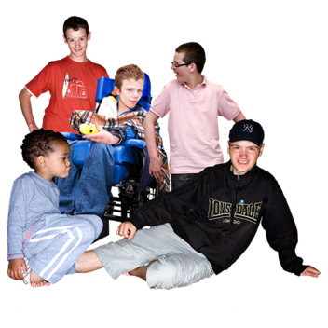
- Young people get more chances to:
lead others
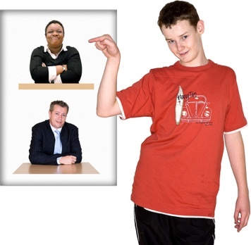
be a part of official groups that:
- make decisions
- give others advice.

How will government agencies

support the Youth Plan?

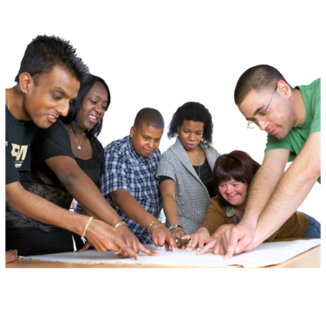
To support the Youth Plan all government agencies must:
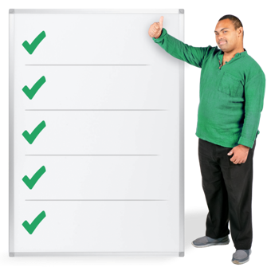
understand the importance of whai wāhitanga of all young people
think about / understand the importance of Mana Taiohi
work with other agencies to fully support the voices of young people
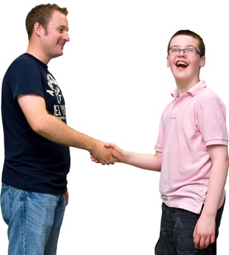
support agencies / communities who work with young people.

There is more information about Mana Taiohi on pages 24 to 28 of this document.

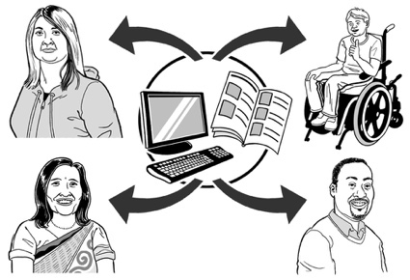
To support the Youth Plan all government agencies must also make sure they:
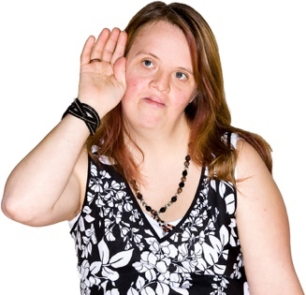
share what they have learned with other agencies so that everyone can learn togther
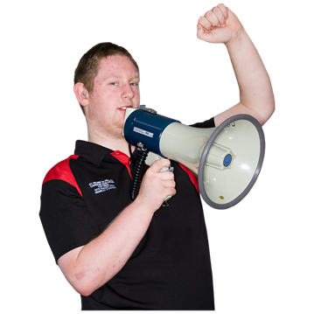
listen to what young people tell them so that changes can be made when needed
give young people who are part of the 7 priority cohorts more chances to have their say.

Tools to support the Youth Plan

Tool 1: Mana Taiohi

Mana Taiohi is a guide for people who work with young people in Aotearoa New Zealand.


Mana Taiohi is based on the understanding of mana.

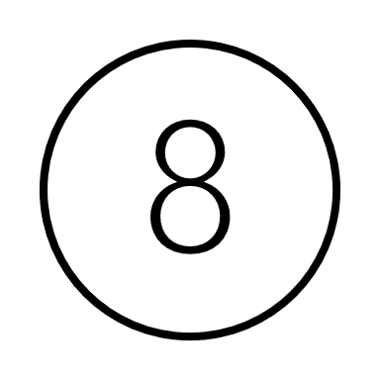
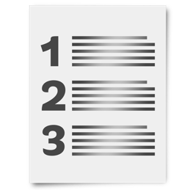
Mana Taiohi also includes 8 other principles that are connected to / work with each other.

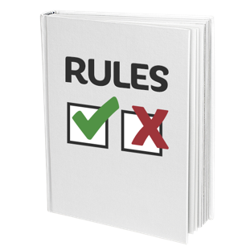
Principles are like rules that tell people how they should behave / act.

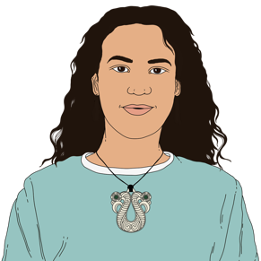
The first 4 principles are about mana that young people have.

The first 4 principles are:
mauri
whakapapa
hononga
te ao.
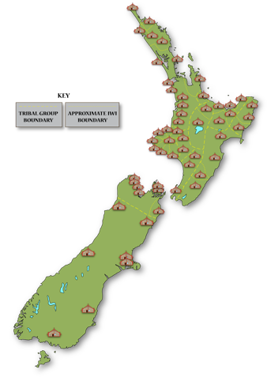
Whakapapa is about how people are connected to:
the land they live in
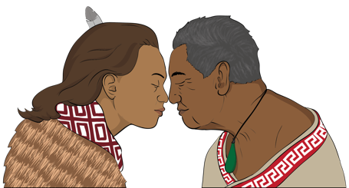
the people who are a part of their whānau / family.
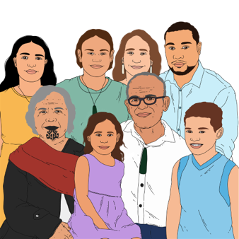
Hononga is linked to whakapapa and is about how people feel the connections to things that make up who they are.

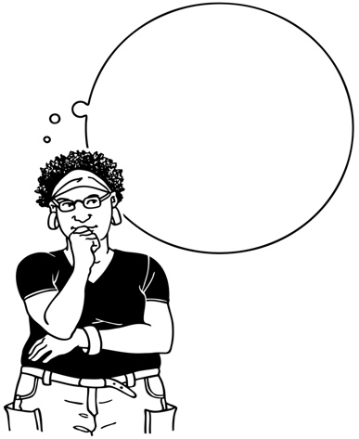
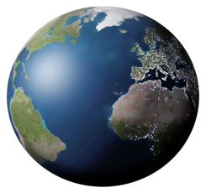
Te ao is about how Māori view / think about:
the world
their place in the world / how they connect to it.


The next 4 principles show how supporting young people can also support / strengthen their mana.

The 4 principles are:
manaakitanga
whai wāhitanga
mātauranga
whanaungatanga.

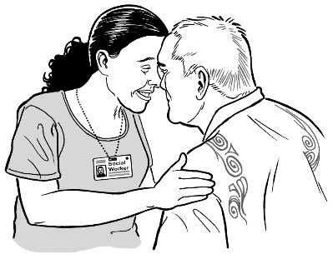
Manaakitanga is about showing respect / care for others.

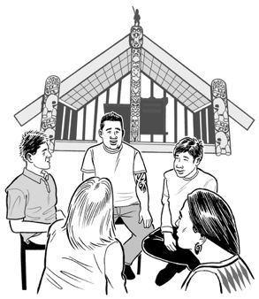
Mātauranga is about knowledge / understanding particularly about things that are important to Māori.
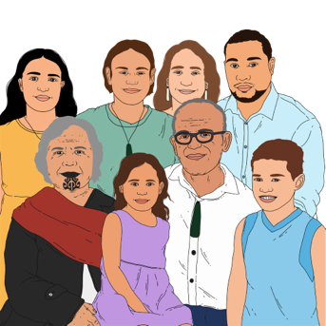

Whanaungatanga is about feeling connections with family / community.


The principles of Mana Taiohi work together to strengthen each other.

Tool 1 supports the Youth Plan by showing the importance of:
listening to young people
giving young people the chance to make decisions about the things that affect them.

Tool 2: Priority cohorts

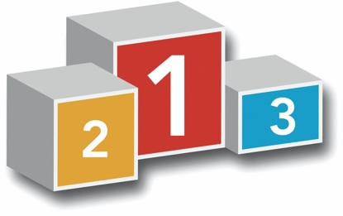
Priority cohorts are the 7 groups listed on page 9 of this document.

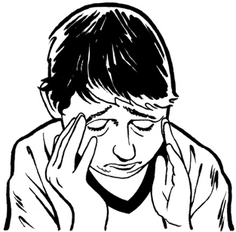
Some groups of young people experience things that affect their overall wellbeing.

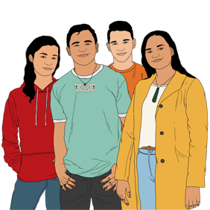
Things that might affect the wellbeing of a young person include:
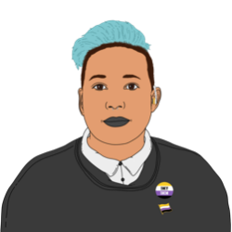
being part of an ethnic community
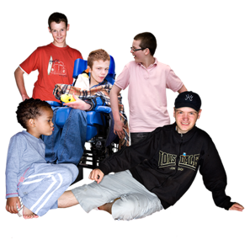
being LGBTTQI+
their gender
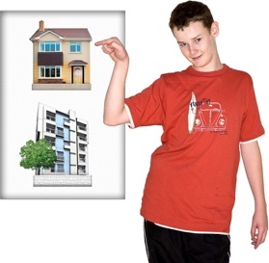
having a disability
where they live.
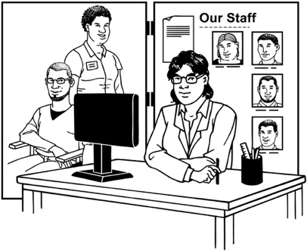
Many of these young people also struggle to access support services:
for things they need
that meet their needs.

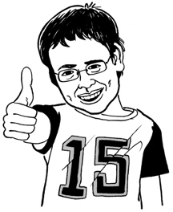
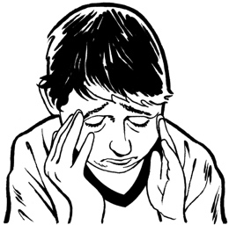
Not every young person has the same experience even if they are part of the same key group.

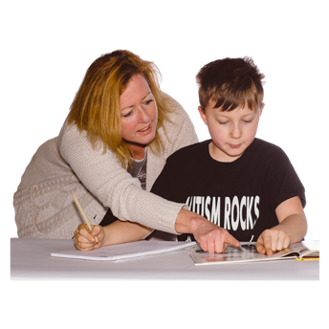
Tool 2 supports the Youth Plan by showing the importance of:
looking at the specific needs of every young person
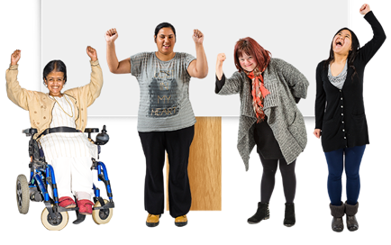
making sure these needs are met so they can succeed / are not held back.

Tool 3: Age range

The Youth Plan is for all young people aged between 12 and 24 years old.
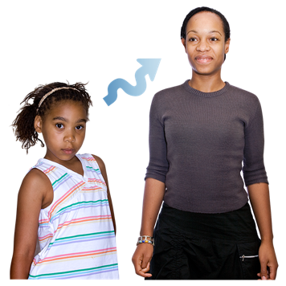

This age group can be split into 2 groups that are about how young people grow / change.

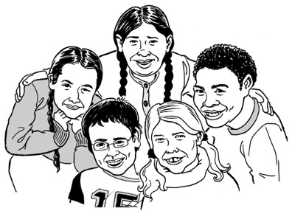
These 2 groups are:
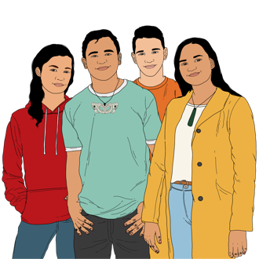
Group 1: young people aged from 12 to 17 years old
Group 2: young people aged from 18 to 24 years old.

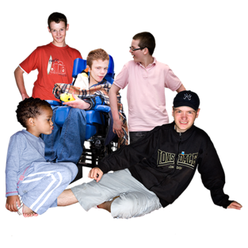
The 2 groups need different kinds of plans as their experiences are likely to be different.
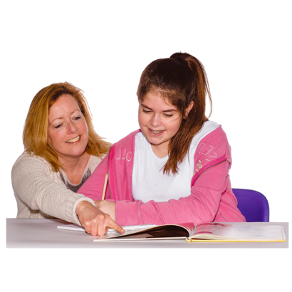
An example of the 2 groups are:
young people in Group 1 are most likely to be in education
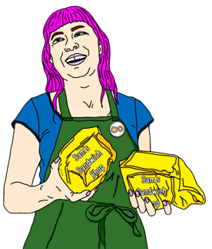
young people in Group 2 are likely to see changes in their lives like:
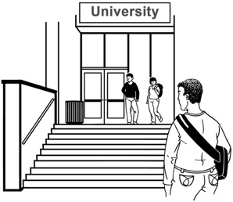
- starting a job
- going to university

- moving out of their family home.

Not every young person has the same experience even if they are:
the same age
part of the same age group.

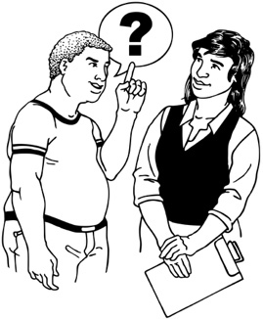
These differences in age / experiences mean that:
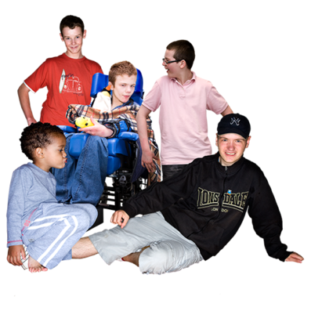
there are a wide range of needs to think about
each of these needs are particular to each young person.

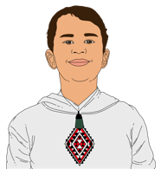
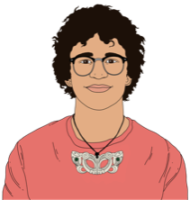
Tool 3 supports the Youth Plan by showing the importance of:
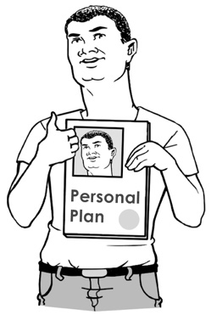
thinking about the experiences of young people of all ages
making sure any plans / changes fit the age groups.

Tool 4: Engagement continuum

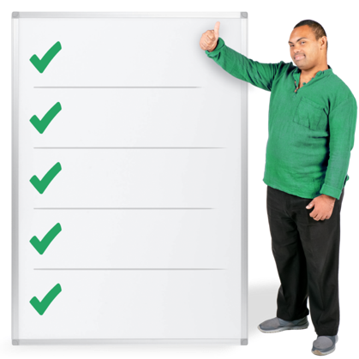
Engagement continuum means that the work done with young people should be done at 5 different levels / stages.


Level 1 – Inform

This means that young people are given the information they need about things that affect them.


Level 2 – Consult

This means that:
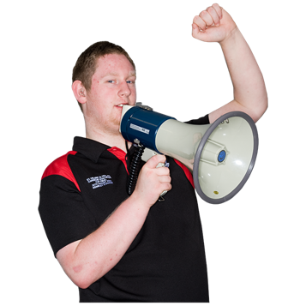
young people have the chance to say what they think about things that affect them
their thoughts / ideas can be a part of making changes.
The other levels that are part of the engagement continuum include:
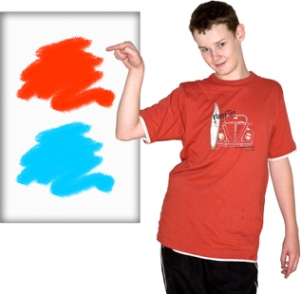
Level 3 – Involve

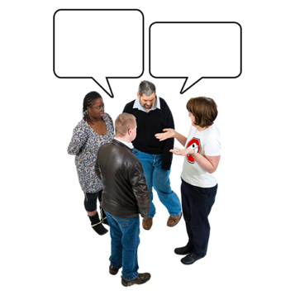
This means that young people are a part of:
showing what things affect them
saying how these things affect them
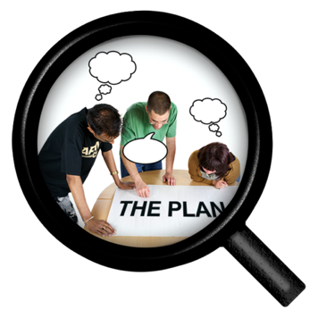
finding ways to deal with these things.

The other levels that are part of the engagement continuum include:
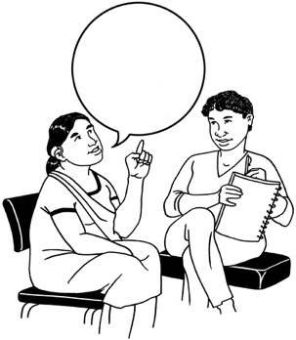
Level 4 – Collaborate

This means that:
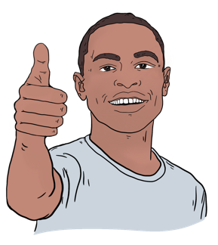
young people are asked what they think / feel about things that affect them
their thoughts / ideas are used to make changes for the better.

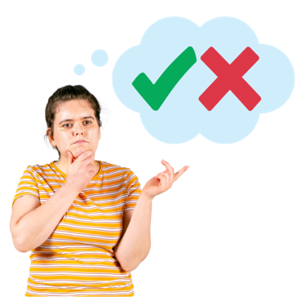
The final level that is part of the engagement continuum is:

Level 5 – Empower

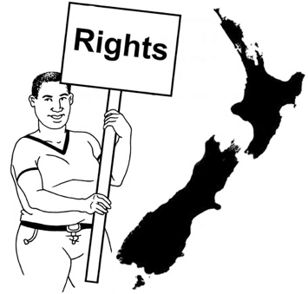
This means that young people are an important part of:
making decisions
leading change.
Tool 4 supports the Youth Plan by showing the importance of working with young people at the level that:
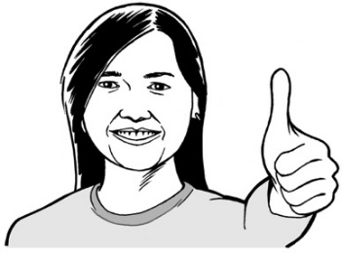
fits them
fits the outcome that is hoped for
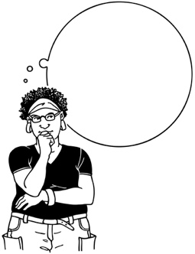
thinks about their experiences
thinks about their skills / knowledge.

Where to find more information

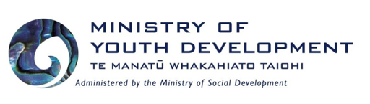
You can contact the Ministry of Youth Development by:

phone on:

0508 367 693

email to

mydinfo@myd.govt.nz

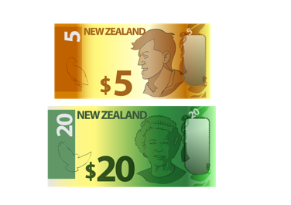
It will not cost you any money to call this phone number.


You can also find more contact details on the Ministry of Youth Development website at:

https://tinyurl.com/4ev7c4nu

This information has been written by Ministry of Youth Development.

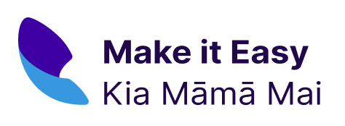
It has been translated into Easy Read by the Make it Easy Kia Māmā Mai service of People First New Zealand Ngā Tāngata Tuatahi.

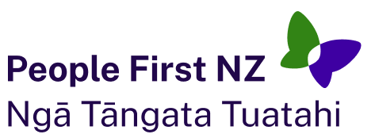
The ideas in this document are not the ideas of People First New Zealand Ngā Tāngata Tuatahi.
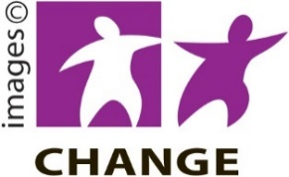
Make it Easy uses images from:


- Changepeople.org

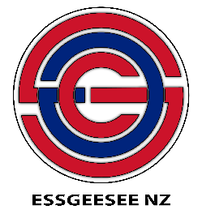
- Photosymbols.com

- SGC Image Works

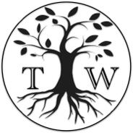
- Huriana Kopeke-Te Aho
- T. Wood.

All images used in this Easy Read document are subject to copyright rules and cannot be used without permission.

