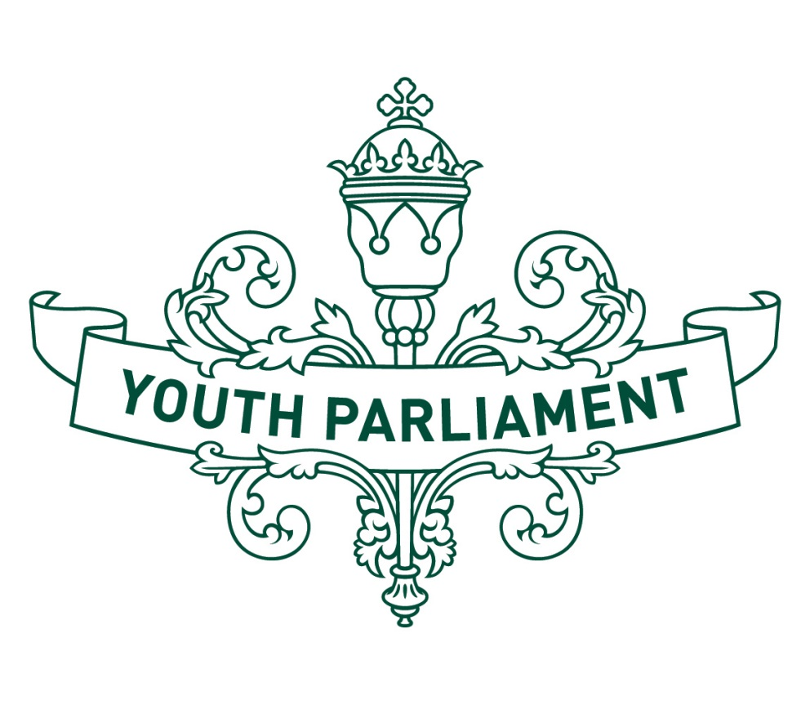  
Youth Parliament 2016

Record of Proceedings:  
Justice and Electoral Select Committee report

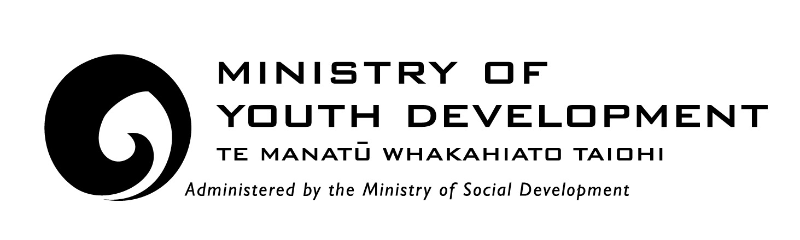



Justice and Electoral Select Committee

**Inquiry into the decriminalisation of recreational drugs**

**Recommendations**

The **Justice and Electoral** Youth Parliament Select Committee makes the following recommendations to the Government:

that it change regulation of Class C cannabis use to prohibition with civil penalties and cautioning

that it monitor the outcomes of the use of these interventions, and if successful, consider decriminalisation. This could also be extended to other recreational drugs or classes of drug

that it promote a health-based approach to recreational drug use

that funding is increased for schools and communities, to provide greater education about recreational drugs and their potential harms

adopt a tiered approach to legislative reform, based on the models that are used in some areas of Australia.

**Introduction**

The purpose of this report is to summarise our consideration of New Zealand’s policy on recreational drugs, and whether recreational drugs should be decriminalised. For the purposes of our inquiry, ‘recreational drugs’ are substances including cannabis, ecstasy, amphetamines, cocaine, opiates, and injected drugs. Alcohol and tobacco are excluded.

**Background**

New Zealand has high levels of substance use, illustrated by a 2007/08 survey which found that about one in two New Zealand adults (49 percent), aged 16 – 64 years had used a prohibited drug for recreational purposes at some stage in their life. Drug use is particularly common among young people in New Zealand, with the most common age of first use of any drug being 15-17 years of age, and one in five people first using drugs at age 14 or younger. We note that Pacific people, Māori, and young people are populations in New Zealand at greater risk of drug-related harms.

We are aware of the harmful effects of substance abuse that have been identified, including poor health, education, and social outcomes. Financial position, employment opportunities, and personal relationships can all be negatively impacted by substance abuse. Additionally, drug use is often linked to crime, and more than 50 percent of crime in New Zealand is committed by people under the influence of drugs and alcohol.

**Defining “decriminalisation”**

Decriminalisation is the lessening of criminal penalties for an action, and ceasing to regard something as a criminal offence. This is not the same as legalisation. Civil penalties could still be imposed for breaches of the law, but punishment of offences would not have a criminal law focus. We consider it important to define decriminalisation, because we initially had differing understandings about its scope and boundaries.

**New Zealand’s current regulatory system (prohibition)**

Under section 7 of the Misuse of Drugs Act 1975, it is an offence to possess or use controlled drugs. Except for the exemptions provided for in the Act, drugs are illegal in New Zealand. Penalties imposed for committing these offences are determined by the activity of the individual, and the relative harm of the drug. For example, penalties are generally more severe for dealing, importing, exporting or manufacturing drugs, as opposed to the possession of drugs. Drugs are classified under the Act according to their risk of harm from misuse. Class A drugs are categorised as a very high risk of harm (e.g. methamphetamine), whereas Class C drugs pose a moderate risk of harm (e.g. cannabis).

We consider that total prohibition is no longer the best approach for the regulation of Class C cannabis possession. We felt it was necessary to specify the class of the drug, as we understand that cannabis oil is categorised as a Class B drug, because it has higher levels of THC and is therefore more potent.

**National Drug Policy 2015 to 2020**

New Zealand’s National Drug Policy sets out the Government’s approach to alcohol and other drug issues, with the primary goal of minimising harm from these substances, and promoting health. New Zealand has high cannabis use rates in young people, and by the age of 21, approximately 80 percent of young New Zealanders will have used cannabis.

Because these issues can have consequences and implications for social outcomes, a cross-agency approach is required. The Government will prioritise resources and assess the effectiveness of government agency and frontline services initiatives. It will also guide and support decision-making by local communities and non-governmental organisations.

The Policy recognises that, to achieve harm minimisation from alcohol and other drug misuse, the Government must take an approach that is compassionate, innovative and proportionate. Help should be easily accessible, and there should be a focus on reducing stigma for drug users. Additionally, a risk and response model should be proportionate to potential harm of a drug, and evidence-based. The Policy recognises drug use as, first and foremost, a health and social issue.

The Policy outlines three strategies for action of problem limitation, demand reduction and supply control. A report of the Law Commission (2011) identifies that the overarching legislation (the Misuse of Drugs Act) is largely neglectful of demand and harm reduction. Additionally, it considers that a focus on supply control requires significant use of law enforcement, justice, and corrections resources.

We agree that New Zealand’s drug policy should focus on harm minimisation. We believe that Class C cannabis use should be treated as a health issue. We also think that the Government should increase funding for education about drug-related harm, particularly for youth, so the issue is addressed as early as possible.

**Summary of submissions**

We heard submissions from three organisations, each with particular knowledge or interest regarding the decriminalisation of recreational drugs.

**Ministry of Justice**

The Ministry of Justice does not have a policy position on decriminalisation. The ministry highlighted the importance of the three action strategies in the National Drug Policy, and we discussed the Misuse of Drugs Act and the drug classification system in greater detail. We heard that New Zealand is a signatory country of three international drug conventions – the United Nations Convention against Illicit Traffic in Narcotic Drugs and Psychotic Substances 1988, the Single Convention on Narcotic Drugs 1961, and the Convention for Limiting the Manufacture and Regulating the Distribution of Narcotic Drugs 1931. We are aware that these may have implications for any proposed changes to policy or the current regulatory system.

**JustSpeak**

We heard that JustSpeak considers that prohibition doesn’t address the causes of offending, which is highly correlated with drug use. It said drug convictions disproportionately impacts Māori and young people (over 80 percent of people in the youth court have a drug or alcohol problem). JustSpeak believes that criminalisation is an ineffective way of dealing with this issue, and that decriminalising recreational drugs is something it could immediately support.

We were told that of the 1,019 drug possession and/or use offences in 2011 for 10 to 16 year olds, 989 were for cannabis-related offences (97 percent). We heard that this is a lower level drug, and we should be looking to support young people and other races. This was particularly important in informing our decision to focus primarily on the regulation of cannabis.

As we are representing a young voice, we expressed our concern at the fact that young people and minority populations are disproportionately represented in these statistics.

**The New Zealand Drug Foundation**

We heard from the New Zealand Drug Foundation, an organisation supportive of decriminalising personal use of recreational drugs. The position of the New Zealand Drug Foundation is based on a harm reduction approach, whereby people should be offered treatment and social support as opposed to being subjected to criminal sanctions. We note that this perspective aligns with the aims of the National Drug Policy.

The New Zealand Drug Foundation considers that decriminalisation would relieve some of the strain on police resources and reduce stigma of recreational drug users, among other positive impacts. This is based on international evidence about exploring options beyond the legal framework of prohibition for drug regulation and drug policy. The New Zealand Drug Foundation recommends an initial decriminalisation for possession of small amounts of cannabis.

We asked whether decriminalisation goes far enough to achieve these intentions and if the New Zealand Drug Foundation would be receptive to legalisation of recreational drugs in future. The New Zealand Drug Foundation told us that the black market still poses problems for decriminalisation, and that legalisation with strict parameters would enable more control over issues such as potency, organised crime, age restrictions, and packaging. We do not believe that there would be widespread support for legalisation in the New Zealand population at this stage. More research needs to be done to assess the potential risks and benefits of this approach.

We support the view of the New Zealand Drug Foundation that these changes could be incremental. We chose to make recommendations with a narrow focus on Class C cannabis, but acknowledge that effects of a new approach to the regulation of this drug could be monitored, with the potential to consider progressing this further, to decriminalisation, if primarily positive outcomes are achieved.

**Case study of cannabis policy in Australia**

Australia and New Zealand are comparable countries with regard to history, societal values, and attitudes towards drug enforcement. Australia also has similar illicit drug usage rates, and indigenous populations suffer disproportionate harm from drugs. Due to the similarities that exist, we believe that we can learn from the approach that Australia has taken to drug regulation, particularly for cannabis. Traditionally, Australia operated under a system of total prohibition. However, there has been an increasing shift to treat cannabis as a health issue as opposed to a criminal issue. As discussed throughout this report, we endorse this approach.

**Prohibition with cautioning**

New South Wales, Victoria, Queensland, and Tasmania apply a “prohibition with cautioning” scheme for minor cannabis offending. Offenders who are caught with small amounts of cannabis (15-50 grams) or with any smoking equipment in their possession agree to complete an intervention as a result of the caution. The cautioning scheme can only be applied if the offender admits to the offence. The offender must participate in an education session on cannabis, attend an assessment session about drug problems, or undergo a drug treatment programme.

If an individual fails to complete an intervention programme, the offender is charged with the original offence. There are restrictions on this scheme, and this varies across states. Generally, cautions can be applied to a first, second, or third cannabis offence, with criminal penalties applying thereafter.

**Prohibition with civil penalty**

Prohibition with civil penalty schemes operates in four Australian jurisdictions – South Australia, the Australian Capital Territory, the Northern Territory, and Western Australia. Similar to cautioning schemes, civil penalty schemes only apply to cannabis possession in small quantities, or cultivation in very small amounts. Offenders are issued a Cannabis Infringement Notice (CIN) which imposes a small fine ($50-$200), or requires the person to attend an education system. Offenders still have the option to have the matter heard and determined in court. As with the cautioning scheme, prosecution will still occur if people fail to adhere to the notice by paying their fine. Again, these schemes are generally not an option for repeat offenders.

**Conclusions**

We recommend prohibition with civil penalties and cautioning for Class C cannabis use, adopting a tiered approach to drug offences, based on the Australian model. We consider that a case-by-case basis should be used, and if an individual fails to comply with the interventions, they can still be charged with a criminal offence. Short jail terms could be imposed for severe offences. We emphasize that this applies only to core personal use (15 – 50 grams), not manufacture, supply, import or export of the drug. We consider that this approach would facilitate many positive outcomes, including:

providing an opportunity to educate and rehabilitate drug offenders

diverting drug users into drug education, assessment, or treatment

promoting a health and well-being approach to drug policy

reducing negative stigmatisation of drug users

a less punitive response to low-level offending, relieving undue pressure on the criminal justice system

taking initial steps to address an issue that disproportionately affects some New Zealand demographic groups.

**Appendix**

**Committee procedure**

The committee met on 19 and 20 July 2016 to consider the inquiry. The committee received and heard three submissions. Evidence was heard from Erin Lubowicz, the Ministry of Justice, Julia Whaipooti, JustSpeak, and Samuel Andrews, the New Zealand Drug Foundation; and advice was received from the Ministry of Justice.

**Committee members**

Hannah Monigatti (Chairperson)  
Michael Daya-Winterbottom  
Cheyenne Te Haara-Barr   
Grace Holmes  
Veronica Manning  
Favor Nweke   
Isacc Proctor  
Javan Rose  
Steph Ross  
Thomas Swinburn  
Ellen Travis  
Jaimee Thomas