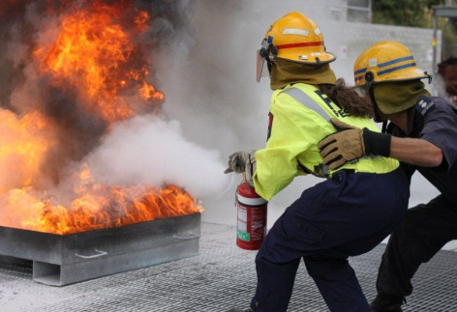
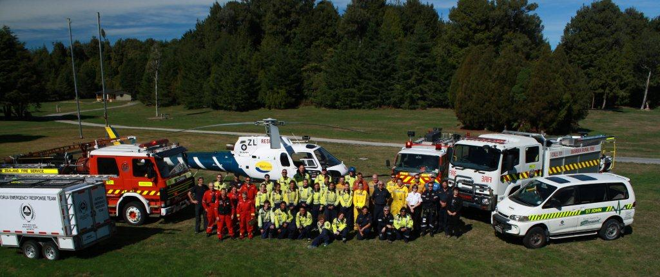
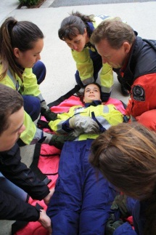

©Alexandra Youth in Emergency Services

Youth in Emergency Services Programme Details

About the Youth in Emergency Services programme
Youth in Emergency Services is a national programme run collaboratively with the Ministry of Youth Development and the Ministry of Civil Defence and Emergency Management and local community-based volunteer emergency service partners.

The Youth in Emergency Services programme is designed to strengthen and encourage young people’s connection to their community by inspiring them to engage with a range of volunteer emergency services by way of a hands-on introduction to the volunteer work of these services.

History of the Youth in Emergency Services programme
The Youth in Emergency Services programme began with a pilot programme in Rotorua in 2013. Following its success the programme was expanded across five new sites and successfully delivered in Kaikohe, Gisborne, Rotorua, Mangakino / Turangi, Kaikoura, and Alexandra in 2014.

In May 2014 the Minister for Youth, Hon Nikki Kaye, announced the expansion of the Youth in Emergency Services programme to a further twenty communities across New Zealand over the next two financial years, through till June 2016.
Read more about the expansion of the Youth in Emergency Services Programme.

People involved in a Youth in Emergency Services programme
Each Youth in Emergency Services programme is driven by a local working group. It is likely to comprise of representatives from the participating volunteer emergency services, local government civil defence group, youth/community development worker (if available), representatives from referring schools/community organisations and groups interested and/or involved in the programme. The working group meets the advisory and governance needs of the programme.

Youth in Emergency Services programme delivery
Local volunteer emergency services, with support from a Youth in Emergency Services Programme coordinator deliver the programme. The local working group determines the structure and processes for elements such as recruiting/selecting programme participants, how on-going support will be provided, ensuring health and safety compliance and designing an engaging and dynamic learning experience for participants.

Structure of the Youth in Emergency Services programme
The Youth in Emergency Services programme is delivered in two parts:
- Phase One consists of an inspiring orientation programme (approximately 40 hours) introducing youth participants to the work of each of the participating local emergency services. This orientation programme introduces participants to the types of skills and knowledge required to work in the volunteer emergency services. They also learn about the volunteers and their experiences. Local volunteer emergency services personnel deliver the training sessions. More information, including an example phase one structure, is available in the Youth in Emergency Services programme report.
- Phase Two consist of each participant being supported to volunteer for a minimum of two months with their chosen emergency service. At the completion of phase two, (the ending of the Youth in Emergency Services programme) participants, in-line with the emergency service’s normal recruitment process, may choose to continue as a formally signed-up volunteer.

Outcomes for the youth participants
The principal outcomes sought for Youth in Emergency Services programme participants are:
- Increased connection to the community
- Acquisition of skills and knowledge and increased emergency preparedness
- Increased personal and social skills
- Actual and/or intention to participate in voluntary activity.

These outcomes are measured through a self-reported participant survey administered by a Youth in Emergency Services programme coordinator at the end of the programme.

Number of young people taking part in the Youth in Emergency Services programme
The optimum group size, based on the experience of the previous Youth in Emergency Services programmes, is 16-20 young people.

Candidate Selection
Each community will recruit suitable young people as candidates sourced from local schools, youth groups, and/or community-based social services agencies. In more rural/smaller communities, where it is viable (for example if transport is available) communities may join together to ensure sufficient numbers of young people can access the programme.

Access to funding in your community
Communities can submit an application to the Ministry of Youth Development though a local legal entity in their community that is prepared to administer the funds, in partnership with local volunteer emergency services and civil defence groups, to deliver the Youth in Emergency Services programme. Currently all the Ministry of Youth Development funding for the 2016 year is allocated for the Youth in Emergency Services Programme.

Deliver a Youth in Emergency Services programme in our community without funding from the Ministry of Youth Development
The Ministry of Youth Development is happy to support communities that are interested in running a Youth in Emergency Services programme and are able to source their own funding. This support would most likely be in assisting the bringing together of a working group for that community, interpreting the ethos of the programme and sharing best practice examples of how to construct a programme, and networking them with previous programme coordinators and emergency services.

Use of funding
Each successful applicant community will receive a maximum of $10,000 through an outcome agreement with the Ministry of Youth Development and a local legal entity. The funding is available to support the delivery of the Youth in Emergency Services programme.
Key components of a successful programme include:
- Having an identifiable Youth in Emergency Services programme coordinator, managed by the working group. This is part-time role comprising 120 to 150 hours on average across the life of the Youth in Emergency Services programme
- A budget to support the scenario weekend (including food and transport)

For more information about the Youth in Emergency Services programme, including previous programmes please contact:
Justine.Johansson004@msd.govt.nz or 04 910 9887.

You can also visit the Ministry of Youth Development’s website at: www.myd.govt.nz .

