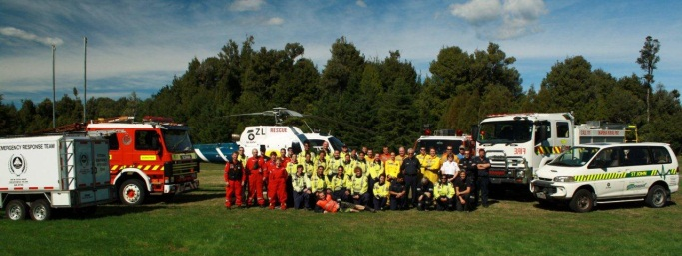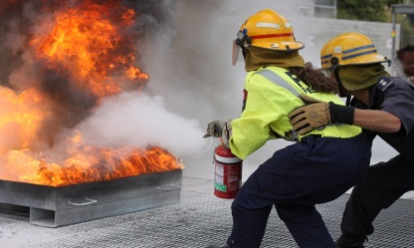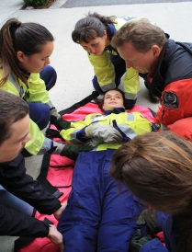

Youth in Emergency Services Programme

TOOLKIT

Prepared by the Ministry of Youth Development (2016)

ACKNOWLEDGEMENTS
We would like to offer our thanks to the many young people who have participated in the Youth in Emergency Services (YES) programme since 2013.
We would also like to thank all of the Emergency Services staff and volunteers, whose willingness to support the young people and the programme has been invaluable. It is their support which has enabled us to continue offering this opportunity to other communities throughout New Zealand.

CONTENTS

Introduction 4

Aims of the programme 5
Governance 6
Project Resources 7
Communications 9
Participant Nominations 10
Participant Consent 11
Safety Management 12
Programme Design 13
Programme Evaluation 14
Reporting 17
Flowchart for programme delivery 18
Appendix One – Frequently Asked Questions 19
Appendix Two – Participant Nomination Form 21
Appendix Three – Participant Consent & Personal Medical Form 23

INTRODUCTION
The YES programme aims to foster an on-going and sustainable relationship between young people and the volunteer emergency services. The YES programme is delivered through two phases.
Phase one consists of a 35-40 hour Orientation Programme introducing participants to the work of each of the local participating emergency services.
Phase two consists of participants undertaking a Volunteering Opportunity, supported by YES programme mentors, for a minimum of 2 months with their chosen emergency service.
The YES programme also reflects Principle 1 and Goal 1 of the National Civil Defence Emergency Management Strategy, which promotes individual and community responsibility and self-reliance in managing local hazard risks. The YES programme aims to foster an on-going and sustainable relationship between young people and the volunteer emergency services.
The Ministry of Youth Development (MYD), in partnership with Ministry of Civil Defence and Emergency Management (MCDEM), will work with community organisations and local emergency services to deliver the YES programme.

AIMS OF THE PROGRAMME
The principal aims of the YES programme are:
- increased connection between young people and their community

- the acquisition, by young people, of the skills necessary to contribute to a
community response in an emergency

- participants’ increased sense of self-confidence, self-esteem and motivation

- increased civic participation by young people

- increased youth development opportunities for young people, that focus on leadership, volunteering and mentoring

- increased capability and resilience for young people.

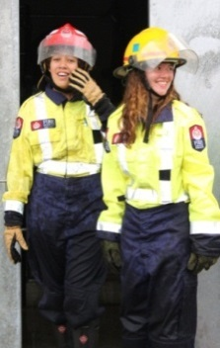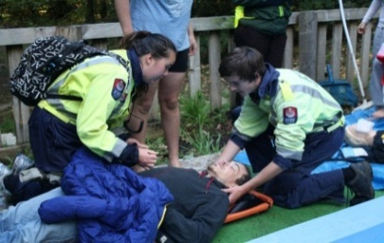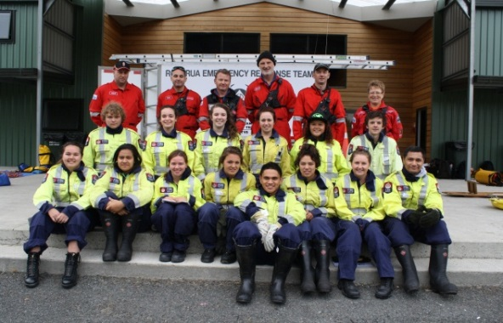
GOVERNANCE

Minister for Youth
Minister for Civil Defence and Emergency Management
Hon. Nikki Kaye

Deputy CE Community Investment
Bryan Wilson

Ministry of Youth Development
Robyn Scott, Director
Julia Walsh, Manager Youth Development
Ministry of Civil Defence and
Emergency Management
Sarah Stuart-Black, Director
Shane Bayley, Manager Development

YES Programme Project Lead
Matt Carnihan, Advisor Youth Development (MYD)

YES Programme Community Working Group
Responsible for design, development and
delivery of YES programmes

PROJECT RESOURCES
The following table details the responsibilities of the various components of your YES programme.
NATIONAL/REGIONAL
MYD |  | Project oversight and governance
MCDEM |  | Project oversight and governance
Ministry of Social Development (MSD) National Communications |  | Media and website communication
MYD Youth Development Team |  | Local communication and support resource
MSD Community Investment |  | Local support, contracting, monitoring and reporting
LOCAL
Project Champion | - chair Working Group meetings  - champion project within own community and across the various emergency services  - ensure the appropriate composition of the Working Group i.e. to include representatives from each of the emergency services which will deliver the Orientation Programme  - champion a longer term mentor / mentee relationship between the emergency services and youth participants.
Working Group | - provide advice and governance over the structure and delivery of the project  - advise Project Coordinator through lesson planning process  - advise Safety Management Coordinator regarding Safety Management Plan (SMP) and Activity Management Plan (AMP).  - review and sign off SMP and all AMPs as a whole group  - oversee evaluation process  Membership of this group may include members of the local Civil Defence, St John, NZ Fire, Rural Fire, Police, Coast Guard, NZ River Rescue and Land Search and Rescue. This group may also include representatives from local secondary schools and Councils.

Project Coordinator | - carry out administrative tasks associated with Working Group meetings e.g. minutes, bookings.  - ensure responsibility for safety management is allocated to one person  - programme design (i.e. planning timetable, scheduling personnel and resources for individual sessions)  - liaise with referral agencies  - conduct programme evaluations  - budget management  - ensure the aims of YES project are understood by referring agencies  - respond to general project enquiries from referring agencies and emergency services  - attend all sessions within Orientation Programme  - ensure evaluations are completed by participants, referring agencies, emergency services and Working Group  - coordinate and facilitate evaluation meetings at 3-months and 6-months  - coordinate graduation process  - ensure that Police checks are completed where appropriate  - assist with transport logistics where necessary.
Youth Participant Support | - disseminate project introduction and nomination forms to all referring agencies  - ensure the aims of YES programme are understood by referring agencies  - respond to nomination process enquiries from referring agencies  - provide a consistent point of contact for any queries or concerns and addressing any personal issues, behaviour or attendance concerns  - provide pastoral care to youth participants, as required, throughout the project  - ensure consent forms are distributed, understood and completed before Orientation Programme begins  - ensure participants clearly understand the Police check process where it is required  - responsibility for photos / video.
Project Safety Coordinators | - ensure SMPs and AMPs are completed, reviewed and agreed by the whole Working Group  - forward SMPs and AMPs to National Quality and Safety Coordinator.
Emergency Services | - Facilitate service specific training sessions including involvement at the Scenario Event Day  - Provide suitable mentors to support participants through Orientation Programme and into a Volunteering Opportunity  - Work with Project Coordinator to ensure a robust process for transitioning youth participants into the service.
COMMUNICATIONS
Your local YES team, and other key stakeholders, may be approached for comment by local media, and others, with an interest in the programme. It may assist you in these communications to refer to the following key messages:
- The YES project aims to strengthen young people’s sense of connection to their community. It does this by linking them with new and challenging opportunities to demonstrate their leadership skills and to experience a sense of contribution and responsibility. The pilot programme suggests that these positive experiences may translate to other parts of their lives.

- The YES programme acknowledges the integral role of the emergency services which are the first-line responders in many emergency situations. They are critical for treating the injured and saving lives. The emergency services, and their volunteers, are also responsible for relief and welfare services in the aftermath of an emergency.

- The YES programme offers young people opportunities to learn new skills and explore possible career options.

- The YES programme aims to increase the capability and resilience of the community in times of need. Individuals and communities must be able to care for themselves and each other, as much as possible, when the normal functions of daily life are disrupted. Communities that can restore the everyday functions of life, with people returning to their homes, businesses reopening and children going back to school, will recover more quickly.

- The YES programme aligns with the priorities of MYD:

  - increasing the number of quality youth development opportunities for young people, particularly those which provide leadership, volunteering and mentoring experiences

  - increasing the proportion of opportunities targeted to youth from disadvantaged backgrounds.
In addition, the following document may be of help with these communications.
Appendix One – YES FAQs

PARTICIPANT NOMINATIONS
Target Group
The programme aims to include a range of young people, particularly those who will benefit most from participating in a challenging programme. Suitable participants will be young people, aged between 16-20 years old, who are motivated, keen to learn, responsible and enjoy tackling new challenges. Participants will be reliable, able to work well in a team and comfortable taking instruction from experienced emergency services personnel.

Nomination Process
Your Working Group may start by identifying all the local social service organisations and/or schools which may nominate young people to the YES programme. Your YES coordination personnel may liaise with the relevant staff within each of these organisations, for example, Gateway Coordinators, or Careers Counsellors, to highlight the aims of the programme and assist with the nomination process. Referral agencies will be asked to provide on-going support to their youth participants, acting as vehicles for sharing information and documentation with participants, such as consent forms. Referral agencies will also be asked to offer support, if required, to those who are not accepted into the programme.
Appendix Two – Participant Nomination Form

PARTICIPANT CONSENT
It is important that all consent information is captured in one consent document and kept confidentially, in accordance with the Privacy Act 1993. It is recognised that personal medical forms should be taken to all field experiences, in which case it is advisable to have the personal medical information on a separate page and a system to ensure confidentiality is maintained while in the field.
Appendix Three – Participant Consent and Personal Medical Forms
SAFETY MANAGEMENT
Safety management across all aspects of the YES programme is paramount, to minimise the opportunity for harm to anyone involved in the programme. In addition to the overall SMP, an Activity Management Plan (AMP) will be developed for the individual activities within the programme.
It is acknowledged, however, that the emergency services, by the nature of their skills, training, experience and job requirements are appropriately equipped to manage the safety of the group whilst in their care.
Many of the facilitators in previous YES programmes are present as part of their employment, meaning the programme could be considered a place of work. Any safety strategy must, therefore, comply with the Health and Safety at Work Act (HSWA) Act 2015.
It is required:
- that each site’s designated Project Safety Coordinator sends their SMP and AMPs to the National Quality and Safety Coordinator for approval before any training sessions begin.
It is recommended:
- that your Working Group identifies one individual to hold overall responsibility for the safety of all involved. This Safety Coordinator should be appropriately qualified and experienced

- that your Working Group formalises, by way of an MOU, the overall SMP and AMPs where appropriate. This MOU will clearly state the safety planning and approval procedure. The SMP and the AMPs should be robust enough to ensure safety while maintaining an appropriate level of risk in the activities

- that your entire Working Group previews the SMP and AMP prior to activities taking place. It is recommended that you also review these plans, as a group, after the activity / programme is completed.

PROGRAMME DESIGN
The YES programme is split into two phases. Phase one consists of a 35-40 hour Orientation Programme, involving hands-on emergency service skills, facilitated by each of the participating emergency services.
While phase one, has at times, been delivered in a one-week block, it is the preference of MYD that phase one is spread out over a minimum of 4-5 weeks (sample shown below)
Phase one culminates in a Scenario Day where participants are able to practice and / or demonstrate the skills learnt during their orientation phase.
Phase One, Week One | Lead Organisation
Thursday 6pm – 8pm | St Johns Ambulance Introduction
Saturday 9am – 1pm | St Johns Ambulance Orientation Experience

Phase One, Week Two
Thursday 6pm – 8pm | New Zealand and Rural Fire Introduction
Saturday 9am – 1pm | New Zealand and Rural Fire Orientation Experience

Phase One, Week Three
Thursday 6pm – 8pm | New Zealand River Rescue and Coast Guard Introduction
Saturday 9am – 1pm | New Zealand River Rescue Orientation Experience

Phase One, Week Four
Thursday 6pm – 8pm | Civil Defence and Emergency Rescue Introduction
Saturday 9am – 1pm | Civil Defence and Emergency Rescue Orientation Experience
Saturday 1pm – 5pm | Land Search and Rescue Orientation Experience

Phase One, Week Five (Scenario Day)
Saturday or Sunday  9am – 4pm | Scenario based activities using rotations from each emergency service, shared lunch with invited family and referral agencies.  Introduction of YES Programme Phase Two

PHASE ONE GRADUATION CEREMONY
Phase Two | Participants undertake a Volunteering Opportunity, supported by YES programme mentors, for a minimum of 2 months with their chosen emergency service.
YES PROGRAMME GRADUATION CEREMONY
PROGRAMME EVALUATION
The YES programme evaluation will reflect:
- the Ministry of Social Development’s Strategic Intentions 2015-2019
- Suicide Prevention Action Plan 2013 – 2016
- the National Civil Defence and Emergency Strategy.
Strategic Intentions
The Ministry of Social Development’s (MSD) Strategic Intentions 2015-2019 sets out the priorities that contribute to the purpose and delivery of Governments priorities.
MSDs purpose is to:
- help New Zealanders help themselves to be safe, strong and independent
The relevant MSD priority that the YES programme contributes to:
- is to ensure more people are able to participate in and contribute positively in their communities and society.
Suicide Prevention Action Plan 2013 - 2016
The New Zealand Suicide Prevention Action Plan 2013 – 2016 outlines a programme of actions that the Government will implement over the next four years. It is a cross-government action plan bringing together the work of eight agencies, including MYD.
MYD is responsible for the following:
Action 1
Build the capacity of Mäori whänau, hapü, iwi, Pasifika families and communities to prevent suicide. The Government cannot prevent suicide without strong partnerships with communities and recognition that suicide prevention is everybody’s responsibility. Communities are often best placed to reach people who are not in contact with government services.
Area 2
Support community-based organisations to create opportunities for young people to be involved in community projects. Identify and share factors associated with successful community suicide prevention programmes.
National Civil Defence and Emergency Management Strategy
The National Civil Defence and Emergency Management Strategy details how CDEM’s vision will be achieved for New Zealand.
The YES programme reflects Principle 1 and Goal 1 of this Strategy, which promotes individual and community responsibility and self-reliance in managing local hazard risks.

Evaluation Package
New surveys will be designed to enable relevant information to be captured.
Who will be surveyed through the YES community programmes?
- young people
- Working Groups
- referral agencies.
Who | Regularity of surveys
 | Pre attending YES Orientation Programme |  | Post attending YES Orientation Programme (at 4 weeks approximately) |  | Post attending YES two month long Orientation Programme (at three months approximately) |  | 6 month survey (three months after completion of Orientation Programme)
 | Required | How | Required | How | Required | How | Required? | How?
Young people | YES | Paper survey at very beginning of Orientation Programme | YES | Paper survey following the completion of the Orientation Programme | YES | Paper survey following the completion of the practice programme, with possible additional focus groups held in 3 sites | TBD | TBD
Working Groups in each site | N/A | N/A | YES | Paper survey or Survey monkey – for MYD to manage process (will mean that we will require email addresses of all Working Group party members | YES | Paper survey or Survey monkey – for MYD to manage process | TBD | TBD
Referral agencies | NA | NA | N/A | N/A | YES | Paper survey or Survey monkey – for MYD to manage process | TBD | TBD
Timeframes
The timeframes for the evaluations to take place will need to be embedded in the contracts. When ready, the survey forms can be added to the toolkit for the communities/programmes to implement.

REPORTING
MYD will require the YES programme provider to return a dataset and participant survey reporting on a regular basis. The following resources have been developed to enable Providers to report against contracted outcomes and to deliver Services for Young People.
Electronic Dataset and Outcomes Reporting Tool
This tool collects the reporting information required MYD for the period 1 July 2016 to 30 June 2017. This Tool has been designed so that you only need the one Tool for the full year, with new and updated information being inputted regularly into this same Tool over the reporting period.
The dataset includes:
- Instructions Sheet – information on how to complete the dataset
- Dataset Sheet – the space where Providers will input the information about the young person and what programmes they are participating in
- Participant questionnaires – questionnaire for the young people to complete at the start and end of each programme
- Summary – provides the findings of the participants’ questionnaires that allows the providers to see how their programme is tracking against contracted outcomes..
Service Delivery
Services Guidelines (attached in YES programme email)
These guidelines are for the Providers that MYD contracts with to provide services for young people.
MYD will require update reports from the Chair of your Working Group.

FLOWCHART FOR PROGRAMME DELIVERY
Open application process for the YES programme

Confirm Funding Panel members and process

Confirm 10 communities to be funded to deliver the YES Programme

Confirm YES Programme Champion

Confirm Working Group members and Programme Coordinator

Select participants

Plan and implement Phase One of YES Programme
(include pre and post programme evaluation)

Phase One Graduation Ceremony

Implement Phase Two of YES Programme

Undertake 3 months feedback process with participants

YES Programme Graduation Ceremony

Reporting on YES Programme

APPENDIX ONE – FREQUENTLY ASKED QUESTIONS
Youth in Emergency Services Programme
Frequently Asked Questions
What is the Youth in Emergency Services (YES) programme?
Youth in Emergency Services (YES) is a national programme run collaboratively with the Ministry of Youth Development (MYD), Ministry of Civil Defence and Emergency Management (MCDEM) and agencies in local communities, such as the local council, schools and volunteer emergency services.
The YES programme is designed to strengthen and encourage young people’s connection to their community by encouraging them to engage with a range of volunteer emergency services.

Is the YES programme new?
The YES programme was piloted in Rotorua during March and April 2013 involving 15 young people aged between 16 and 18. Following the pilot, young people reported an increase in a connection to their community, and several participants indicated their experience enabled them to actively participate in their communities.
Since 2013 a further 25 YES programmes have been completed.

How is the YES programme structured?
The YES programme starts with an Orientation Programme for young people. This introduces them to the skills they need to work in the various volunteer emergency services.
Local emergency services are invited to deliver training sessions to young people. Following the Orientation Programme, young people will have the opportunity to demonstrate these skills in a range of group scenarios in real life settings.

How is the YES programme delivered?
Emergency Services, with support from a YES Programme Coordinator, will deliver the programme. The local Working Group will determine the structure and processes of elements such as recruiting young people and how on-going support will be provided.

Who will be involved in a YES programme?
Each YES programme will be driven by a local Working Group, likely to comprise of community representatives of the volunteer emergency services, local council, schools and other relevant organisations interested and/or involved in the programme. The Working Group will meet the advisory and governance needs of the programme.

What is MYD’s role in the YES programmes?
MYD will provide information taken from previous YES programmes to guide new YES programmes. This includes information on candidate recruitment, programme design, evaluation and risk management.
In addition to this, MYD will be on hand to provide information and advice to each YES programme.

How can emergency services get involved in a YES programme?
For more information on how to get involved in a YES programme in your community, please contact Matt Carnihan, Advisor MYD (contact details are below).

I am interested in supporting a YES programme, how can I get involved?
For further information on how to get involved in a YES programme in your community, please contact Matt Carnihan, Advisor MYD, (contact details are below).

How many young people take part in the YES programme?
There is space for up to 15 young people in each community YES programme.

How are young people selected for the YES programme?
Each community will recruit suitable candidates (aged between 16 and 20 years) from their local schools and/or local social services agency.

What happens after the YES programme?
Each young person will have the option of volunteering in an emergency service following their completion of the Orientation Programme.

Where can I go for more information on the YES programme?
For further information on the YES programme, please contact;
Matt Carnihan, Advisor Youth Development
DDI: (04) 916 3778
Email: matt.carnihan006@msd.govt.nz

You can also visit our website at: www.myd.govt.nz for further details on the
YES Programme

APPENDIX TWO - Participant Nomination Form
YOUTH IN EMERGENCY SERVICES PROGRAMME
NOMINATION FORM

The Youth in Emergency Services project is a collaborative initiative which aims to strengthen the connection between young people and their communities by way of a hands-on introduction to the work of the emergency services in their area. Young people will have the opportunity to contribute to their community whilst gaining marketable employment skills and an insight into potential career pathways. They may also become active voluntary members of an emergency service.

NOMINATIONS CLOSE: <insert date>

Suitable candidates will:

- be aged between 16-20 years old
- be motivated and committed
- have good self-management skills
- be available to attend the Orientation Programme on <insert date>
- be in good health and be physically able

Participant’s Details

Name ____________________________ DOB ______/______/______
Gender ____________________________ Ethnicity ________________
Address ___________________________ Phone __________________
____________________________

Have you ever been convicted of any criminal conviction other than minor traffic offences?
YES / NO (circle one)
If you answered YES, please provide details below
________________________________________________________________________
________________________________________________________________________
________________________________________________________________________
I agree that I am committed and would like to be involved in the Youth in Emergency Services programme for 2016/2017.

Name Signature
_____________________________ _______________________________

This section is to be filled out by the organisation / provider / school who is nominating the young person

Name ____________________________________
Work Address ____________________________________
____________________________________
____________________________________

Phone (wk) ____________________ Phone (mob) ______________________
Email ___________________________________________________________________

In what ways is this young person suitable for nomination to this programme?

________________________________________________________________________
________________________________________________________________________
________________________________________________________________________
________________________________________________________________________

Signature _________________________

Send your nominations to: <insert Local Programme Coordinator> by <insert date>
Successful nominees (and their nominators) will be notified by <insert date>. If you have any questions about the application process or form, please contact <insert name and contact number>.
Note: There is a police vetting process on all nominations and each will be considered on a case by case basis.

APPENDIX THREE - Participant Consent & Personal Medical Form
YOUTH IN EMERGENCY SERVICES PROGRAMME
GENERAL CONSENT FORM FOR
PARTICIPANTS AND PARENTS/GUARDIANS

Participants on the Youth in Emergency Services Project (YES) will have the opportunity to experience a range of core emergency service activities. Safety has been a paramount consideration in the development of the YES project. To this end:

- All YES project activities require staff to undertake an analysis of the risks, and identify the management strategies required to eliminate, isolate and/or minimise the risks.

- We will discuss with participants any potential hazards and how to manage these and will brief participants on safety requirements.

- All YES project activities are planned and facilitated by highly experienced emergency service specialists who hold a variety of relevant qualifications.

Acknowledgement of Risk
I understand that there are risks associated with involvement in the YES project including water, height, motor vehicles, fire and cold amongst others, and that while all these risks will be managed during the project, they cannot be completely eliminated. I understand that the YES team will identify any foreseeable risks or hazards and implement correct management procedures to eliminate, isolate or minimise those hazards.

I know that I am able to ask any questions of the YES team about the activities which I will be involved in. I recognise that participation in such activities is voluntary and not mandatory. I understand that I may withdraw from an activity if I feel at risk. This must be done in consultation with the session facilitator and / or YES support staff.

In understand that the YES team does not accept responsibility for loss or damage to personal property and that it is my responsibility to check my own insurance policy.

Transport
I give permission for the YES team to transport me as part of a YES activity if necessary
Name: ______________________________________
Date of Birth ______________________________________
Address ______________________________________
______________________________________
Contact Number Home _____________ Mobile _____________
Drivers Licence (circle) None Learner Restricted Full (circle one)

Tick
I have read and signed the attached YES Project General Consent Form which outlines the type of activities which I may participate in, as well as the risk management procedures which are in place.
I acknowledge that the YES project team will use medical and contact details that have been supplied within this consent form to help with the risk management. I understand that it is my responsibility to update all contact and health information as and when needed by contacting the YES Project Coordinator with new information.
I can confirm that I (please tick)
- can swim 25m unassisted
- am confident in a pool
- am confident in deep water
- am confident in the sea or open inland water
- am able to tread water
- am able to survival float
I am aware that consent here does not eliminate the need for activity leaders to ascertain the level of the participants’ swimming ability for themselves.
I have declared all medical or health conditions or swimming ability information that could affect my participation in the YES project and/or other circumstances that may be relevant between now and the commencement of the YES project.
I give permission for the YES team to store the attached consent, contact, health and swimming information securely and make it available to the personnel involved in planning and facilitating the training sessions.
I agree to receive any emergency medical, dental, or surgical treatment, including anaesthetic or blood transfusion, as considered necessary by the medical authorities present.
I understand that should I act in a way considered unacceptable by YES project staff, or put myself or others in any danger, I may be asked to withdraw from the YES project. I understand that the costs (transport and staffing) will be at my expense and that I will be sent home at a time convenient to YES staff.
I can confirm that I am in good health and able to participate in these types of activities
I give my consent to be a member of the YES project and to attend training
I give my consent to YES photographing me and/or filming me during my involvement with YES. In agreeing to this, I understand that my image may be used for the following purposes:
- Publications and promotions
- Internal and external film clips and DVDs
- Internal and external websites

_________________________ ______________________
Signed (participant) Date
________________________________ ____________________________
Parent/Guardian Name Signed
(if participant is under 18 years of age)
_________________________
Date

